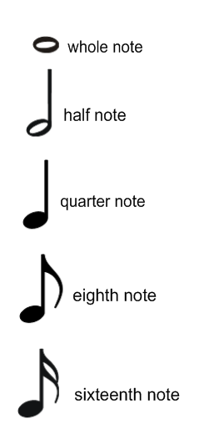
Use this to help you review for your theory quiz. How many beats is each note worth? Draw the corresponding rest sign beside the note.

How do you know what a dotted half note is worth?

What is the format for major scales?

