"Chatham, 3rd June, 1847 "Captain Thain [sic], of the ship Loostauk, [sic] 636 tons, from Liverpool to Quebec, out 7 weeks, had, when she left Liverpool, 349 passengers, out of which 117 have died, and of the ship's crew only five are able to work. The ship's sails are much split, and the jib and foresail are carried away. Within the last three days 35 of the passengers have died; and out of the whole number on board, not more than 20 have escaped sickness. The Captain requires immediate assistance to bring the ship up the river. One hundred of the passengers are sick and the crew unable to work. The Captain says that he and his crew will be compelled to leave the ship, unless assistance is sent, as they consider their lives in danger. Six of the passengers were committed to the deep, five or six miles from Escuminac, yesterday. In the early states of the disease, the sick are seized with delirium, and dysentery follows and soon carries them off."

Barque

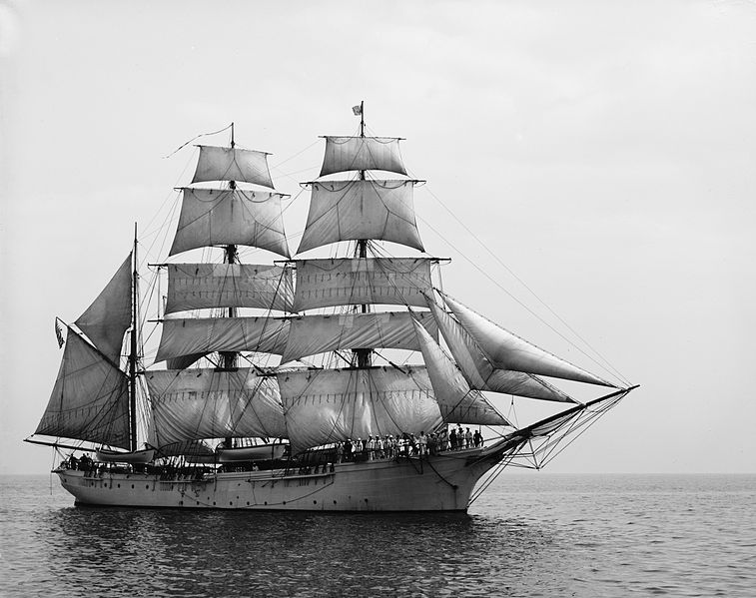

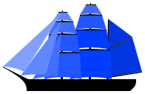
The word barc appears to have come from Celtic languages. The form adopted by English, perhaps from Irish, was bark, which gave rise to the French barge and barque. Well before the 19th century a barge had become interpreted as a small vessel of coastal or inland waters. Somewhat later, a bark became a sailing vessel of a distinctive rig as detailed below. In Britain, by the mid-19th century, the spelling had taken on the French form of barque. Francis Bacon used this form of the word as early as 1605.
The usual convention is that spelling barque refers to a ship and bark to tree hide, to distinguish the homophones.

Barque / Bark
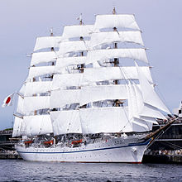
Four-masted barque Nippon Maru II
In the 18th century, the British Royal Navy used the term bark for a nondescript vessel that did not fit any of its usual categories. Thus, when the British Admiralty purchased a collier for use by James Cook in his journey of exploration, she was registered as HM Bark Endeavour to distinguish her from another Endeavour, a sloop already in service at the time. She happened to be a ship-rigged sailing vessel with a plain bluff bow and a full stern with windows.
William Falconer's Dictionary of the Marine defined "bark", as "a general name given to small ships: it is however peculiarly appropriated by seamen to those which carry three masts without a mizen topsail. Our northern mariners, who are trained in the coal-trade, apply this distinction to a broad-sterned ship, which carries no ornamental figure on the stem or prow."^{[2]}
The UK's National Archives states^{[citation needed]} that there is a paper document surviving from the 16th century in the Cheshire and Chester Archives and Local Studies Service, which notes the names of Robert Ratclyfe, owner of the bark "Sunday" and 10 mariners appointed to serve under Rt. Hon. the Earl of Sussex, Lord Deputy of Ireland.

Barque rig
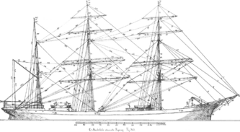
Rigging of a three-masted barque
By the end of the 18th century the term barque (sometimes, particularly in the USA, spelled bark) came to refer to any vessel with a particular type of sail-plan. This comprises three (or more) masts, fore-and-aft sails on the aftermost mast and square sails on all other masts. Barques were the workhorse of the Golden Age of Sail in the mid-19th century as they attained passages that nearly matched full rigged ships but could operate with smaller crews.
The advantage of these rigs was that they needed smaller (therefore cheaper) crews than a comparable full-rigged ship or brig-rigged vessel as there were fewer of the labour intensive square sails, and the rig itself is cheaper. Conversely, the ship rig tended to be retained for training vessels where the larger the crew, the more seamen were trained.
Another advantage is that a barque can outperform a schooner or barkentine, and is both easier to handle and better at going to windward than a full-rigged ship. While a full-rigged ship is the best runner available, and while fore-and-aft rigged vessels are the best at going to windward, the barque is often the best compromise, and combines the best elements of these two.
