Term 3: Sciences Humaines: 6/7D and 7L

Textbook

In term three, we will finish two more units from the textbook ‘Un monde en changement: Le dévelopement de l’autonomie,’ upon which the curricular outcomes for S.H. program are based:

Unit 5: L’autonomisation sociale

Unit 6: L’autonomisation nationale

The focus of each unit is twofold. For the first, larger focus, the students will learn the concepts of each unit. Their understanding will be assessed by quizzes and projects. As well, each student is to keep a journal where what we talk about in class or read about in the text is kept. The journal is not primarily for copying information (although if a student chooses to do this it is ok), but more for adding personal ideas and reflections about what we learn. For the second, the students will spend some time learning about common process skills involved in the Social Sciences and Humanities (ex: pre-reading strategies for informative texts).

Current Events and Historical Retrospectives

In addition, the students will also be analyzing and reflecting upon current events from ‘Le monde en marche,’ and taking a glimpse into various historical epochs by relating current forms of empowerment to those of the past. These will be assessed by completion of a project or activity (reflection essay, journal entry, presentation, group work).

Participation in class and completion of homework will also be assessed.

Mark Distribution
Textbook
20% - Quizzes
20% - Projects
20% - Journal

CE and HR
25% - Projects

Other
15% -Homework and Participation

Term 3: Sciences 6V

Outline

In term three, we will complete unit 3 from the curriculum: L’électricité.

Unit 1: La sécurité en électricité

Unit 2: Examen de l’électricité statique

Unit 3: Les circuits

Unit 4: Les électroaimants et leurs applications

Each unit is based primarily on the activities and concepts outlined in the curriculum document. The document’s approach is based in problem solving and learning through exploration, which is proven to be one of the best approaches to reaching multiple styles of learning. In addition, the Pan Canadian Science Place will be used occasionally to supplement what we discover through experiments. Unit 3 will follow the resource ‘Ressources didactiques en sciences: 6e année: L’électricité: La circulation du courant.

Assessment
The students will be responsible to maintain a science journal, where they are free to write notes or, more importantly for assessment purposes, write down ideas that come to them throughout the course. The journal’s mark will depend on it being maintained, organized and that it shows evidence of personal thoughts/reflections.
At this stage, students are expected to learn both the concepts of the material and the process skills involved in a science classroom. Summative assessment will be based on both understanding of concepts and process skills. These will include quizzes/tests and activities/projects for each unit. There may be multiple quizzes during a unit with a test at the end, as well as multiple activities during a unit with a final project.
Homework and class participation also make up part of the mark.

Mark Distribution

10% - Quizzes
20% - Test
10% - Activities
20% - Projects
20% - Journal
20% - Homework and Participation

Term 3: Post Français Intensif: 7F and 7R

Overview

Unit 3: La Publicité

The Intensive French program has 3 major components: Oral, Reading, Writing. Each new language concept starts with and Oral component and is followed by a Reading and Writing component, but in order for the latter two to be effective, the first must be learned. It is difficult to move forward if not everyone has learned the Oral part, so the participation and attention of the students during Oral activities is crucial. Therefore the overall mark is broken into four components: Oral, Reading, Writing and Participation. The last is primarily concerned with, but not completely limited to, participation during Oral activities.
Intensive French requires the presence of the teacher during all activities to scaffold learning. Therefore, homework, outside of the occasional lecture, is not recommended and so it does not make up part of the mark.
In addition, various activities will be included to enhance the P.F.I. guide, such as videos, physical activities, puzzles and dramatic presentations.
The activities, projects and functions of communication are listed below.

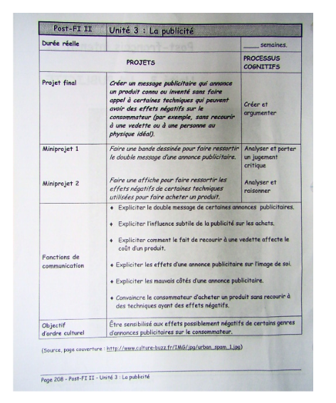
Mark Distribution

25% - Oral
25% - Lecture
25% - Écriture
25% - Participation
Term 3: Santé: 7L and 7D

Overview

We will be completing unit 4 in the provincial curriculum this term:

4) Croissance et développement physique

Some of the Health class activities will be based in classroom discussion, discussions with partners and larger groups with a consolidation occurring at the end of the class. Participation and contributions that are authentic will be the focus of evaluation for such activities. Activities will include videos, visual representations, drama, and physical activities. Students will be given choice on how to complete most assignments to suit their learning style (dramatic scenes, in writing, pictures, comic strip).

Projects, labs, and quizzes will make up the remainder of evaluation.

Mark Distribution

50% - Participation and Contribution
20% - Projects
20% - Quizzes
10% - Labs

Term 3: Santé: 6V and 6D

Overview

We will be completing unit 4 in the provincial curriculum this term:

4) Croissance et développement physique

Some of the Health class activities will be based in classroom discussion, discussions with partners and larger groups with a consolidation occurring at the end of the class. Participation and contributions that are authentic will be the focus of evaluation for such activities. Activities will include videos, visual representations, drama, and physical activities. Students will be given choice on how to complete most assignments to suit their learning style (dramatic scenes, in writing, pictures, comic strip).

Projects, labs, and quizzes will make up the remainder of evaluation.

Mark Distribution

50% - Participation and Contribution
20% - Projects
20% - Quizzes
10% - Labs

Term 3: Physical Education: 7L

*Part of 7L’s gym time shared with Mr. Corlett’s 6V class. We will be mirroring what they are doing throughout the year. On Monday, when it is just 7L in the gym, I will teach specific skills and concepts and on Thursday, when both classes share the gym, the focus will be on application of the skills and concepts.

Student assessment is divided into three components. The “Doing” component of the curriculum will represent 60% of the PE mark. This component requires daily participation, effort and preparedness, as well as the demonstration of efficient and effective movement skills. The “Knowing” component of hte curriculum will represent 20% of the PE mark. This element involves the understanding of an activity, applying knowledge to a variety of circumstances, and maintaining a personal level of fitness. The “Valuing” component will be 20% of the mark. This component requires the demonstration of fair play, cooperation, leadership skills, and social development.

The daily 5 point system already used by the gym teachers will be followed in this class as well.

5/5: Prepared, Participating and not being disruptive to the learning environment
4/5: Performing unsafe acts, poor sportsmanship, disruptive
3/4: Participating but not completely prepared (sneakers but no change of clothes), reduced effort,
2/4: Non-dressed but participating
0: Non-dressed/non active, being insubordinate, fighting

