Term 2: Post Français Intensif: 8R and 8M

Overview

Unit 1: Le mode de vie d’autrefois

The Intensive French program has 3 major components: Oral, Reading, Writing. Each new language concept starts with and Oral component and is followed by a Reading and Writing component, but in order for the latter two to be effective, the first must be learned. It is difficult to move forward if not everyone has learned the Oral part, so the participation and attention of the students during Oral activities is crucial. Therefore the overall mark is broken into four components: Oral, Reading, Writing and Participation. The last is primarily concerned with, but not completely limited to, participation during Oral activities.
Intensive French requires the presence of the teacher during all activities to scaffold learning. Therefore, homework, outside of the occasional lecture, is not recommended and so it does not make up part of the mark.
The activities, projects and functions of communication are listed below.

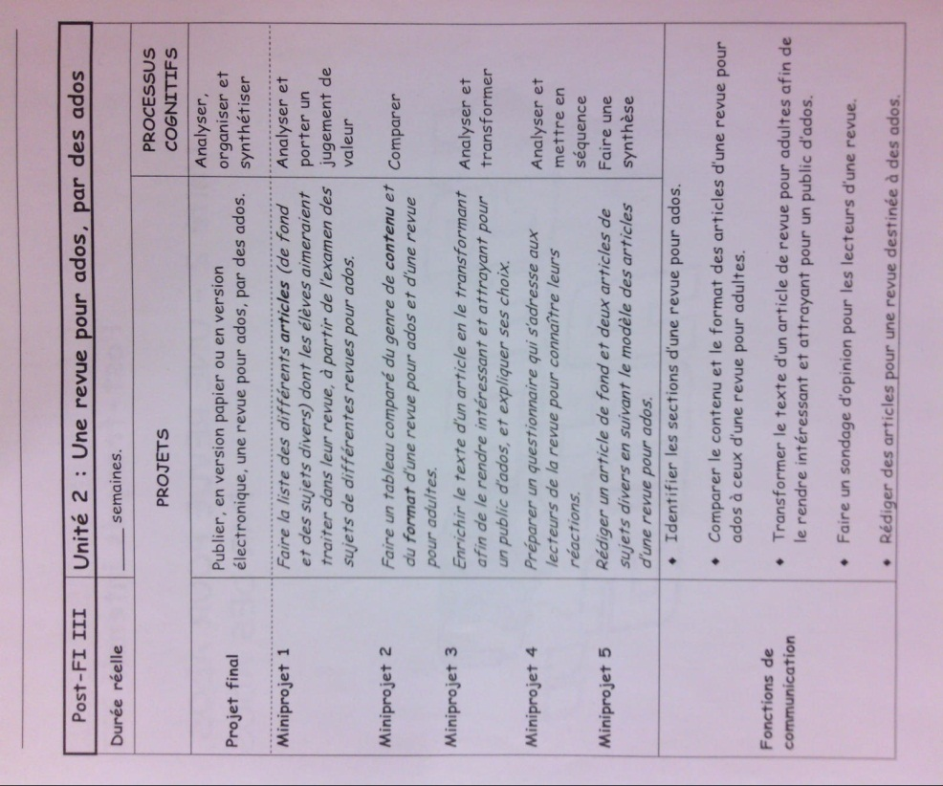
Mark Distribution

25% - Oral 25% - Lecture
25% - Écriture 25% - Participation

