Homework Assignment #2
- Use tiles to model each integer in two different ways. Draw the tiles. (6 points)
  - -5
  - +3
  - 0
- What sum does each set of tiles model? Write the addition equations. (8 points)
  - 6 yellow tiles and 1 red tile
  - 5 yellow tiles and 7 red tiles
  - 4 yellow tiles and 4 red tiles
  - 2 red tiles and 3 yellow tiles
- Use a number line to add the following equations. (8 points)
  - (-10) + (+8)
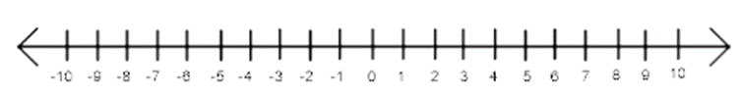
  - (+6) + (-5)
  - (-5) + (+12)
  - (-8) + (+8)
- Write an addition equation for each situation. (6 points)
  - Mike earned $50, and spent $20. How much did Mike then have?
  - The temperature is 5°C, then drops 10°C. What is the final temperature?
  - A city has 52 000 people. A new factory opens and 500 people move to town. What is the new population of the city?
- Write the addition equation modelled by each number line. (4 points)
  - 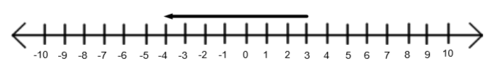
  - 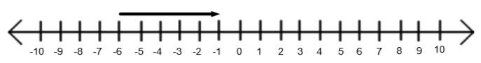
- Subtract (8 points)
  - (-4) – (-1)
  - (-9) – (+5)
  - (+8) – (-2)
  - (+4) – (+5)

