The Return of Birds
Springtime has finally arrived, and birds are returning to our backyards!
Over 5000 different bird species migrate in the spring and fall months every year?
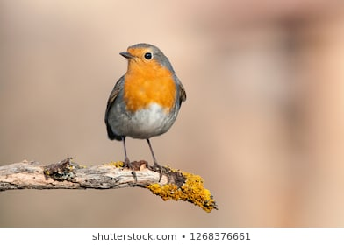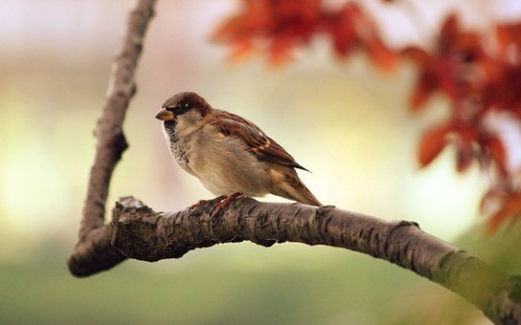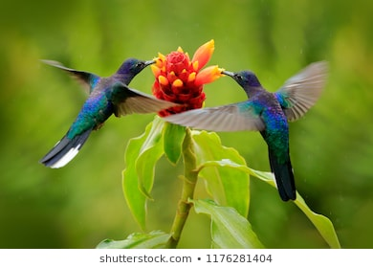

Activity
- Go for a walk around your neighbourhood. (Respect social distancing of course!) Other family member living in your household might like to accompany you.

If you have a cellphone, you can download a bird identification « App» or a bird song identification « App ». A few examples are : « Merlin Bird ID » or « Smart Bird ID ». (There are many others……)
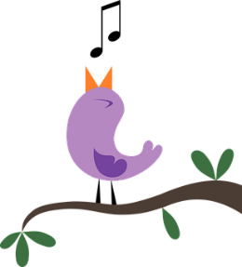

*****Do not panic if you don’t have a cellphone. You will be able to look up Web sites when you get home.

If you have a cellphone, try to get pictures of the birds you see or record their songs. If you prefer, you can take a short video. These will help you when trying to identify them.
Observations
- How many birds do you hear? Do they all sound the same?

- How many birds do you see? How many different species do you see?

****While you are walking in your neighbourhood, don’t forget to breath in all that fresh air and take notice of all the signs around you that Mother Nature is waking up after her long winter nap.

- Watch the following video https://www.youtube.com/watch?v=CwIT9pv4khw

Research Questions
- What does the word migrate mean?

- Why do birds leave in the fall?

- How do birds know it’s time to go?
- Where do birds migrate to when they leave in the fall? How do they know where to go? (They don’t have a GPS system)

- What is New Brunswick’s provincial bird? Draw a picture of that bird.

Name of bird : _____________________________

