Perimeter Magic Triangle
To create the triangle:
- Draw a large triangle on a sheet of paper (you can use a ruler to help make straight lines).
- Use a quarter to trace a circle on each corner of the triangle and in the middle of each side. You should have six circles.
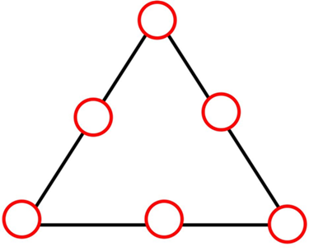

To create the number disks:
  - Draw six circles similar in size to the ones drawn on the triangle. Use a sheet of paper with a contrasting color if possible.
  - Cut out these circles, and number them 1 through 6.
Choose 21 small objects that stack easily. Pennies, math cubes and stackable candy are all good choices.

Procedure
- On the paper with the triangle use the 21 pennies (small blocks or stackable objects) to build towers on each circle. Each circle must have at least 1 penny, but no two circles can have the same number of pennies (or no two towers can be of the same height).
- Keep trying until you find a solution!
- Count the number of pennies (or objects) in each tower. Write these numbers down in order from the smallest to the largest number.
Shift the towers around or rebuild them until you can fulfill one more requirement: The total number of pennies used to build the three towers on each side of the triangle must be the same. For example:
- If you build towers of 1, 5 and 3 pennies in the circles lining up on one side of the triangle, you used 1 + 5 + 3 = 9 pennies on that side.
- If working with abstract numbers is easier for you, replace the towers with the number disks. Each number disks then represents a tower of pennies. The number written on the number disks informs you of the number of pennies in that tower.

