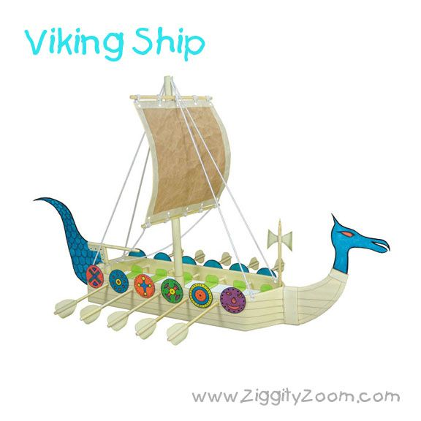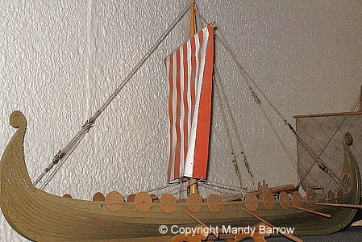

Basics of Viking Ship Construction
- Viking ships weren't built around a skeleton-like hull as were other ships of their time. The Vikings fastened overlapping planks to a single keel, shaping the hull with planks. Floor timbers were then attached to the keel to add flexibility. After that, cross beams for decks and as seats for rowers were added. Finally, a massive beam ran alongside the keel to serve as support for the mast.
Viking ships were vessels used during the Viking Age in Northern Europe. Scandinavian tradition of shipbuilding during the Viking Age was characterized by slender and flexible boats, with symmetrical ends with true keel. They were clinker built, which is the overlapping of planks riveted together. They might have had a dragon's head or other circular object protruding from the bow and stern, for design, although this is only inferred from historical sources.
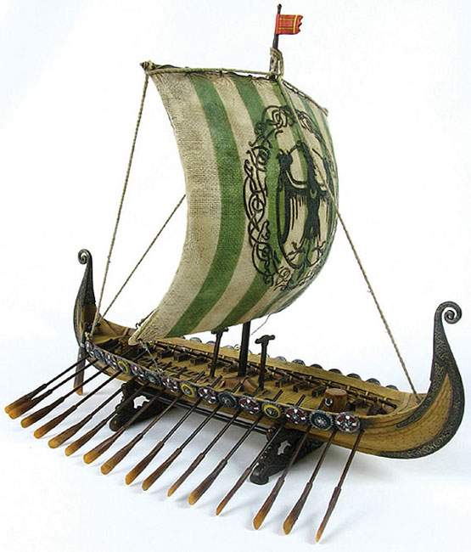
Arguably the greatest achievement of the Vikings was their boat and shipbuilding. The Vikings were not the first people to build ships but they did build the best ships anyone had made up to that time.
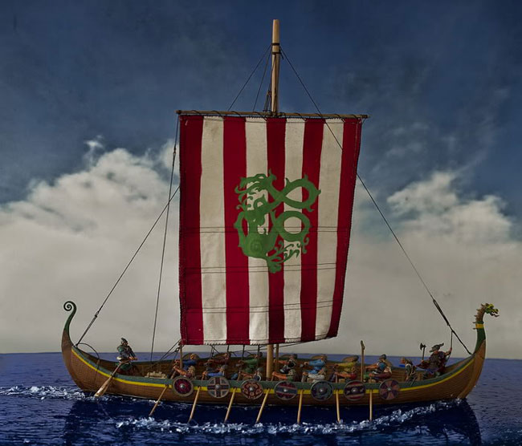
The hull is made up of overlapping planks of wood that are held together with iron rivets. This construction is both strong and flexible, qualities necessary for ocean going vessels.
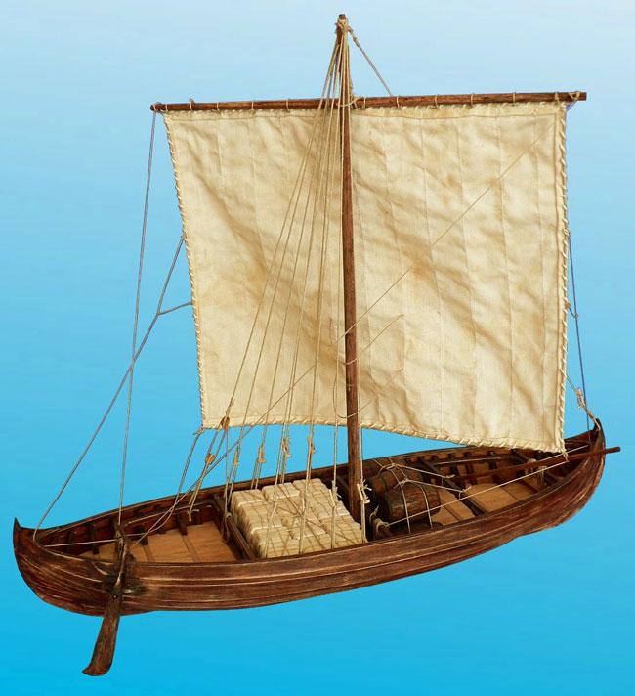
To maintain this flexibility, the hull of some ships was fixed to the main timber frame with ties rather than nails.
Viking ships were pointed at each end and wide in the middle, this often meant that they could sail in relatively shallow waters.
It would appear that ships did not have permanent oar benches so the crew must have sat on sea chests to row the ship.
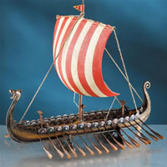
At the right side of the ship near the back is a large paddle tied to the hull for steering. This practice gives us the term still used for the right side of a boat “starboard” from the old words “steor”- rudder or steering paddle + “bord”- ship’s side. For many years the left side was called “larboard” from the words “laden”- to load + “bord” this arises because to prevent the steering paddle from being damaged the boat was landed with the quay on the left so they could be loaded.
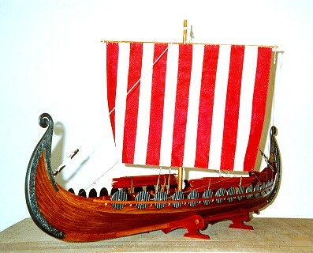
Sea going vessels were often mounted with a dragon or serpents head on the prow. It is important to remember that most people of the Viking age were very superstitious by our standards. The dragon head was simply to frighten away sea monsters and spirits. When approaching land the head could be removed to prevent scaring off the friendly land spirits.
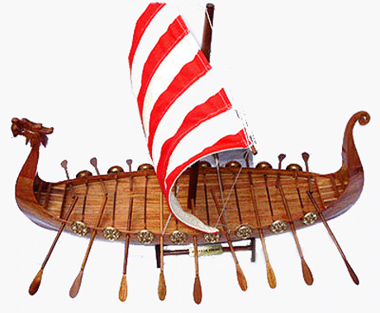
In recent generations, the war ship has become the cultural icon of the Vikings. This trend is not particularly shocking, as the ship functioned as the centerpiece of Scandinavian culture for centuries. In fact, the importance of the Viking ship is deeply rooted in Scandinavian culture, as the vessel served both pragmatic and religious purposes. Scandinavia is a region with relatively high inland mountain ranges and easy access to coastal ports. Consequently, trade routes primarily operated via shipping, as inland trading was both hazardous and cumbersome. Viking kingdoms thus developed into coastal cities, all of which were deeply dependent on the North Sea for survival and development. Control of the waterways was then of critical importance, and consequently the most advanced war ships were in high demand. In fact, because of their overwhelming importance, ships became a mainstay of the Viking pagan religion, as they evolved into symbols of power and prowess. Throughout the first millennia, respectable Viking chieftains and noblemen were commonly buried with an intact, luxurious ship to transport them to the afterlife. Furthermore, the Hedeby coins, among the earliest known Danish currency, have ships as emblems, showing the importance of naval vessels in the area. Through such cultural and practical significance, the Viking ship progressed into the most powerful, advanced naval vessel in Viking Age Europe
