Considerable skill is required to build a crannog. To begin with rafts and boats must have been used, as well as wooden scaffolding built out in the loch. The first stage was to create an artificial island out of timber piles. Alder trees, 8-10m long, were used for the piles. Buoyant on water, the alder piles would have been easy to manoeuvre on the water's surface but very difficult and tiresome to pull vertical.
One of the most challenging tasks the archaeologists faced was how to drive the alder piles up to 2m into the lochbed using only Iron Age technology.
A crosspole would have been lashed to the upright pile and twisted back and forth to create enough momentum to drive it two metres into the loch bed. It has been estimated that it would have taken 12 days for the Iron Age builders to erect and secure the 168 piles needed.
Once the piles were driven, the platform and roundhouse of the crannog could be jointed, pegged and lashed onto the structure. Round timber poles were used for the flooring and to form the structure of the roundhouse. Its roof was thatched with reeds from the loch, with its enclosing walls made from hundreds of flexible hazel stems woven together.
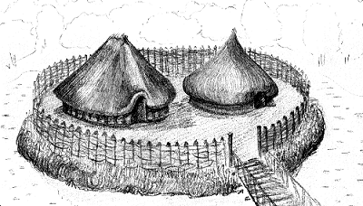

An Introduction to Crannogs.

The term Crannog refers to small artificial islands which can be found in the majority of Scotland’s lochs and inland waters. From the surface, most crannogs look like uninteresting mounds of stone, from which timbers sometimes protrude. These small islands were constructed and occasionally lived on by people, as recently as the 17 th century. Today, crannogs are one of the most exciting and complex sites on which archaeologists work. From research carried out over the course of the last hundred years, archaeologists have discovered a substantial amount of information concerning the form, structure, date range, and location of crannogs.
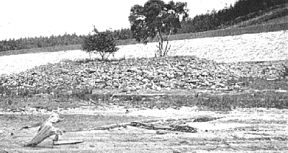
A Crannog in Loch Treig. (After Ritchie 1942)

Most crannogs are to some extent artificial. This means that it has taken a certain amount of human activity to create them. In some cases, small islands or natural bedrock outcrops were only slightly enlarged, requiring relatively little effort. In other cases, crannogs were created from scratch by piling up vast amounts of materials on the loch bed. This obviously required substantial effort and considerable time. Regardless of the effort the product is always very similar- a small island, its surface protruding above the water surface, which owes its existence to human activity. Other features which are also found on crannogs include: approach causeways from the shore, vertical wooden piles set into the lochbed, middens of discarded domestic waste, harbours and jetties.
Crannogs can take a variety of forms. Most are circular or oval, but differ greatly in size. Average surface diameters range between 15 and 30 m, although there are notable exceptions both larger and smaller. The materials used to build Crannogs vary throughout Scotland. Crannogs found in the Hebrides seem to have been built primarily of stone whereas those found in mainland were predominantly built of wood. Most of this variation has been ascribed to differences in local environments. In general, people used materials which were easy to come by or immediately at hand.
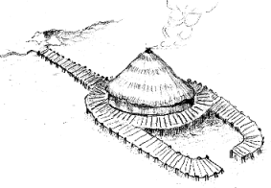
A free standing, stilt type crannog.
At the moment archaeologists believe that there are fundamentally two types of crannogs. One has a solid base and is literally an island, the other is a type of raised structure, such as a stilt house or large dock. This later type stood above the water and was substantially taller. It is often impossible to tell which type of structure a particular crannog is without excavating it.
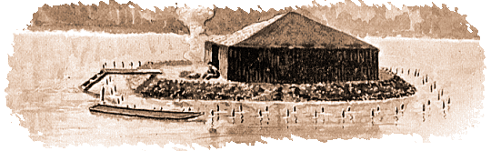
A solid base type crannog. (After Ritchie 1942)
Evidence suggests that Crannogs have been used as habitation sites for a period longer than any other type of structure in Scotland’s history. Literary evidence indicates that crannogs were still being used in remote areas of Scotland until the seventeenth century. Archaeological excavations have shown that crannogs were used during various periods ranging from Roman times (80-400 A.D.), the Bronze Age (2000-500 B.C.), and the Neolithic (4000-2000 B.C.) This extensive time range makes it very hard to know when a particular crannog was in use.
Crannogs offer an unparalleled opportunity of recovering information about Scotland’s past. Because Scotland’s lochs are so cold, and relatively bacteria free, organic materials such as wood, seeds and plant fibre are often well preserved. Recently a 2500 year old butter dish was found underwater on a crannog site. The amazing thing was that there was butter still in it. Such superb preservation helps archaeologists piece together what life on a crannog was actually like, in a way that can't be achieved on dryland sites. Crannogs are an important cultural resource and if properly managed they can give a unique view of Scotland’s past.

Crannogs are a type of ancient loch-dwelling found throughout Scotland and Ireland, while one has been discovered in Wales in Llangorse Lake. Most are circular structures that seem to have been built as individual homes to accommodate extended families. Other types of loch settlements are also found in Scandinavian countries and throughout Europe.
Crannogs are also known as artificial or modified natural islands and they were as much a product of their environment as the period in which they were constructed.
The authentic crannog reconstruction which forms the focal part of the Scottish Crannog Centre was built by the Scottish Trust for Underwater Archaeology or STUA. The Scottish Trust for Underwater Archaeology is a registered charity (number SCO18418) and was formed to promote the research, recording, and preservation of Scotland's underwater heritage.
The earliest loch-dwelling in Scotland is some 5,000 years old but people built, modified, and re-used crannogs in Scotland up until the 17th century AD. Throughout their long history crannogs served as farmers' homesteads, status symbols, refuges in times of trouble, hunting and fishing stations, and even holiday residences. Here in Highland Perthshire, the prehistoric crannogs were originally timber-built roundhouses supported on piles or stilts driven into the lochbed.
In more barren environments and in later periods tons of rock were piled onto the lochbed to make an island on which to build a stone house. Today the crannogs appear as tree-covered islands or remain hidden as submerged stony mounds. Several hundred have been discovered so far in Scotland although only a few have been investigated. For a guide book providing more information about Scottish crannogs, contact us at info@crannog.co.uk.

Reconstructing a Crannog
How did the ancient people build their crannogs in the water? Our team of underwater archaeologists carried out a unique experiment to find out and re-discovered the secrets of ancient technology. For further details see our Experimental Archaeology section.

