HILL FORTS
A hill fort is a type of earthworks used as a fortified refuge or defended settlement, located to exploit a rise in elevation for defensive advantage. They are typically European and of the Bronze and Iron Ages. Some were used in the post-Roman period. The fortification usually follows the contours of a hill, consisting of one or more lines of earthworks, with stockades or defensive walls, and external ditches. Hill forts developed in the Late Bronze and Early Iron Age, roughly the start of the first millennium BC, and were in use in many Celtic areas of central and western Europe until the Roman conquest.

Ireland [edit]
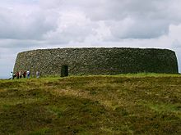
Exterior view of Grianan of Aileach situated in County Donegal
Bronze Age and Iron Age hill forts are widely found in Ireland. They are large circular structures between 1 and 40 acres (most commonly 5–10 acres) in size, enclosed by a stone wall or earthen rampart or both. These would have been important tribal centres where the chief or king of the area would live with his extended family and support themselves by farming and renting cattle to their underlings.
There are around 40 known hill forts known in Ireland. About 12 are multivallate as distinguished by multiple ramparts, or a large counterscarp (outer bank). The imposing example at Mooghaun is defended by multiple stone walls. One must be careful to not confuse a hill-fort with a 'ringfort' a medieval settlement a common archaeological feature across the whole island of Ireland, over 40,000 examples are known.
Some hill forts have cairns inside their boundaries and there are many speculations about this phenomenon, the theories range from being a strange cult religion to just coincidence the same kind of area as they both like (hill tops with commanding views of the local vicinity), the excavation at Freestone Hill in County Kilkenny has shown that there was indeed a ditch cut out around the cairn, evidence that they had respect for the feature no matter what they believed about it.

Beyond the simple definition of hill fort, there is a wide variation in types and periods from the Bronze Age to the Middle Ages. Here are some considerations of general appearance and topology, which can be assessed without archaeological excavation:
- Location
  - Hilltop Contour: the classic hill fort; an inland location with a hilltop defensive position surrounded by artificial ramparts or steep natural slopes. Examples: Brent Knoll, Mount Ipf.
  - Inland Promontory: an inland defensive position on a ridge or spur with steep slopes on 2 or 3 sides, and artificial ramparts on the level approaches. Example: Lambert's Castle.
  - Interfluvial: a promontory above the confluence of two rivers, or in the bend of a meander. Examples: Kelheim, Miholjanec.
  - Lowland: an inland location without special defensive advantages (except perhaps marshes), but surrounded by artificial ramparts; typical of later settled oppida. Examples: Maiden Castle, Stonea Camp.
  - Sea Cliff: a semi-circular crescent of ramparts backing on to a straight sea cliff; common on rocky Atlantic coasts, such as Ireland. Examples: Daw's Castle, Dinas Dinlle, Dún Aengus.
  - Sea Promontory: a linear earthwork across a narrow neck of land leading to a peninsula with steep cliffs to the sea on three sides; common on indented Atlantic coasts, such as Ireland, Cornwall, Brittany and west Wales. Examples: Huelgoat; The Rumps and other promontory forts of Cornwall.
  - Sloping Enclosure: smaller earthwork on gently sloping hillsides; not significant defensive position. Examples: Goosehill Camp, Plainsfield Camp, Trendle Ring.
- Area
  - > 20 ha: very large enclosures, too diffuse to defend, probably used for domesticated animals. Example: Bindon Hill.
  - 1–20 ha: defended areas large enough to support permanent tribal settlement. Example: Scratchbury Camp
  - < 1 ha: small enclosures, more likely to be individual farmsteads or animal pens. Example: Trendle Ring.
- Ramparts, walls and ditches
  - Univallate: a single circuit of ramparts for enclosure and defence. Example: Solsbury Hill.
  - Bivallate : a double circuit of defensive earthworks. Example: Battlesbury Camp.
  - Multivallate: more than one layer of defensive earthworks, outer works might not be complete circuits, but defend the weakest approaches; typically the inner circuit is original, with outer circuits added later. Example: Cadbury Castle.
- Entrances
  - Simple opening: might indicate an enclosure, rather than a defended position; sometimes the main ramparts may turn inward or outward, and be widened and heightened to control the entrance. Example: Dowsborough.
  - Linear holloway: straight parallel pair of ramparts dominating the entrance; projecting either inward, outward, or occasionally overlapped along the main rampart. Example: Norton Camp.
  - Complex: multiple overlapping outer works; staggered or interleaved multivallate ramparts; zig-zag entrance way, sling platforms and well planned lines of fire. Example: Maiden Castle.
Some forts were also settlements, while others were only occupied seasonally, or in times of strife. Archaeological excavation reveals more about the dates of occupation and modes of use. Typical features for excavation include:
- Ramparts and ditches
  - Original depths and profiles of ditches.
  - Rampart construction: murus gallicus, pfostenschlitzmauer.
  - Guardhouses and defended entrances.
- Settlement and occupation
  - Raised platforms, roundhouses, longhouses.
  - Post holes for rectangular granary huts.
  - Pits for food storage, souterrains, fogous.
  - Pottery
  - Coins, jewellery and hoards.
- Temples and peacetime burials
  - Platforms and temple foundations.
  - Graves and offerings
- Warfare
  - Weapons: sling-shot, shields, armour, swords, axes, spears, arrows.
  - Sieges and conquest: ballista bolts, ash layers, vitrified stones, burnt post holes.
  - Wartime burials: typically outside the ramparts:
    - Contemporary individual burials by local inhabitants.
    - Massed grave pits dug by a conquering army.
Mooghaun hillfort (spelled Moghane in Irish), located in Co. Clare, is thought to be the largest hillfort in Ireland. Built just after 1260-930 B.C., it is situated "on a low hillock in a fairly gently undulating landscape of good agricultural land dotted with many small lakes" (Grogan 1993: 39). It sits 80m above sea level and with an area of 27 acres (12 hectares) it dominates the surrounding landscape. Mooghaun is located in the grounds of Drumoland castle and provides extensive views of the Shannon estuary. It is a trivallate hillfort, meaning it has three circular ramparts all of which are contained within one another. The outer wall encloses 27.18 acres, the middle enclosure contains 7.41 acres and the inner enclosure contains 2.04 acres (Grogan 1993). | 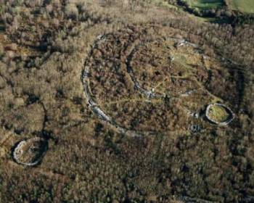

The ramparts can be as much as 12m wide in some places and over 2m in height (Grogan 1993).The middle enclosure has an entrance in the northeast and the inner enclosure has an entrance on the West side. Along the Northwestern area of the outer wall is a cashel of a later date; another is found along the southwest corner of the inner wall and several can be found near the site as well (Grogan 1993). All of the walls are made of limestone and appear to be constructed so as to take advantage of the natural contours of the landscape.

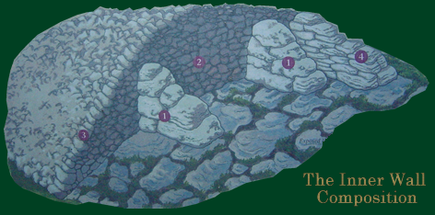 | Excavations  Mooghaun hillfort seems to have first appeared in the archaeological literature in 1893 in an article by T.J. Westropp who studied and mapped it extensively, but conducted no excavations (Waddell 1998). It was again studied in 1981 by E. Cody, but systematic excavations did not begin until 1992. As part of the North Munster project of the Discovery

Programmearchaeologists Isabel Bennett and Eoin Grogan began excavations at Mooghaun. The Discovery Programme is a state funded program which is dedicated to understanding Irish history and heritage with a strong emphasis on the late prehistory of Ireland.
The purpose of the North Munster project was to "to access the nature and range of settlement, economic, social and ritual patterning in a regional framework and in this way to achieve a detailed view of the processes and changes involved within later prehistory"(Grogan 2002). The sites in this area show a high amount of wealth and complexity during the late Bronze Age and the Early Iron Age. The study hoped to better understand the emergence of regional centers in the area and the transitory period between the Bronze and Iron Age. During the 1992 season, areas along the southwest area of the outer wall, inside of

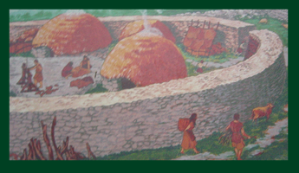 | enclosure one were excavated [the cashel in the Southwest area of the middle wall] (Grogan 1993). Other excavation areas were conducted in the southwest side of the middle enclosure and areas thought to have been entrances were examined as well. Excavations in 1993 were centered in the inner ring and along the northern border of the outer ring and in 1994 the team excavated several areas in the North, Southeast and Southwest as well as two cuts into the inner enclosure wall. During their work at Mooghaun the Discovery Programme was responsible for the clearing of vegetation from the site (14,000 m^2 in

1994) and has revealed more features at the sight (Grogan 1996). The North Munster project also used their survey data and computer programs such as auto cad to make 3D representations and 3D topographical maps. By assuming that the mound was mostly limestone they concluded that the mound has a volume of 15.60 m^3 (Shaw 2002). In addition to the work at Mooghaun, as part of the North Munster project excavations and surveys of the surrounding area were conducted. Small habitation sites at Lough Gur and Aughinish seem to be contemporary and may have had economic or ritual connections (Grogan 2002). Excavations of Mooghaun and the surrounding area continued from 1992 - 1994 and may have continued till 1996 but no information is currently available about this later work.

Excavations at Mooghaun have revealed some evidence of occupation yet none is contemporary with the ramparts. Although evidence of occupation exists in the layer beneath the ramparts, there was no lapse in time between the abandonment of the occupation and the construction of the hillfort. The remains of three huts were found Southwest of the middle enclosure after tree clearing and a fourth was identified to the West of the middle wall (Grogan 1996). Further evidence for previous occupation was found under | 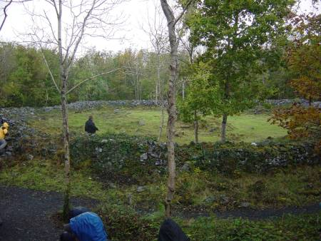

the ramparts in a "black sticky deposit" which contained ceramics and a large quantity of unburned animal bone (Grogan 1996). In general, the site has produced ceramic remains and animal bones. The ceramic style is similar to those found at nearby Bronze Age sites including Knocknalappa which is 4 km South of Mooghaun and one bronze artifact has been found which indicates a Late Bronze Age use of the site. The aforementioned radio carbon date of 1260-930 B.C. was found underneath the outer wall which means that the wall was actually built sometime afterwards. Of the four later houses identified, only two of them have been excavated. They are encircled by a rubble filled stone wall of around 1m in thickness and have a diameter of about 4 m (Grogan 1996). The roofs of both would have been held up by a post in the middle. House 1 contained chert, animal bone and fire cracked rock. House 3 contained more animal bone, chert and a blue glass bead. Excavators also found that the site House 3 was built upon had been prepared by a leveling of the bedrock beneath the house (Grogan 1996).
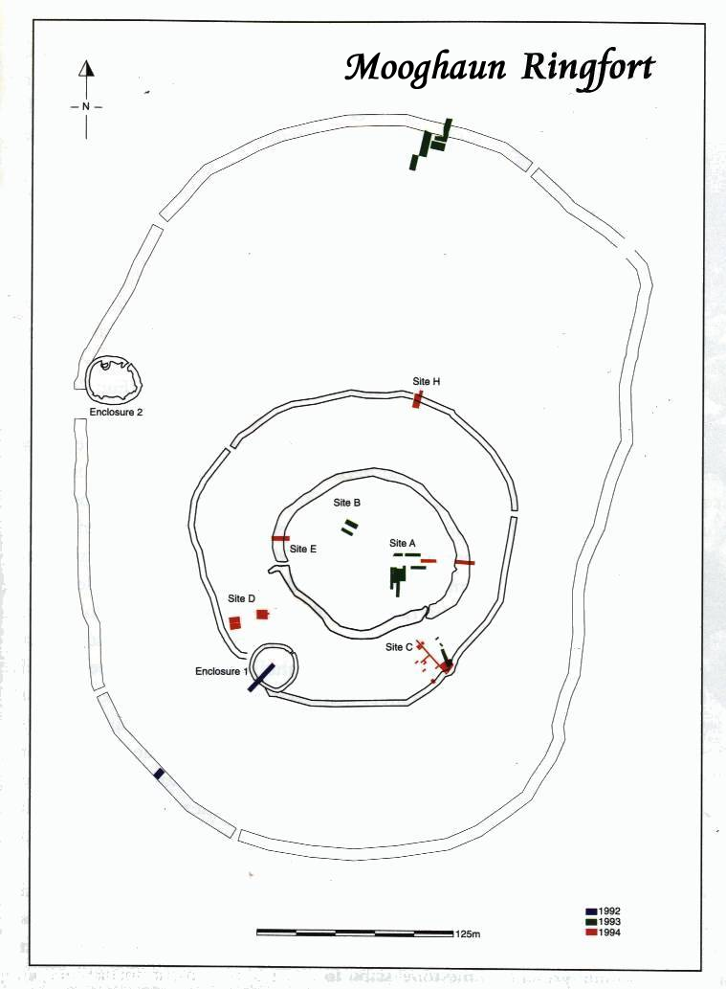
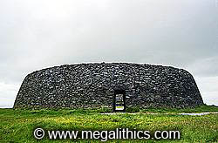 |  | 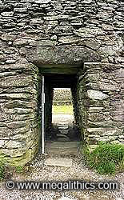 |  | 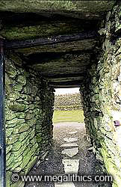
The exterior form the east. |  | The entrance doorway. |  | Inside the entrance passage.

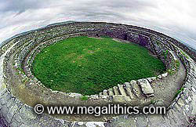 |  |  |  | 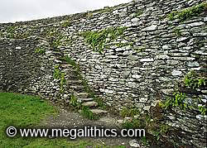
Interior and walls. |  | The SE arc of the interior walls. |  | Oblique view of SE stairways.

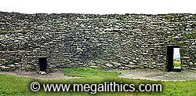 |  | 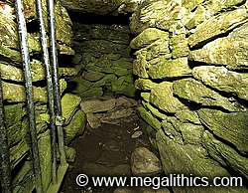 |  | 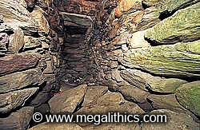
NE arc of interior walls. |  | The entrance to the NE wall passages. |  | The northern arm of the NE passages.

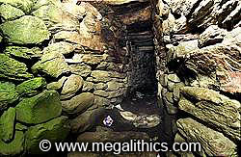 |  | 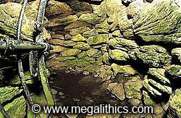 |  | 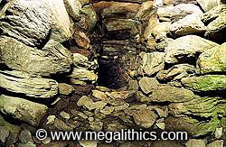
The southern arm of the NE passages. |  | Entrance to the SE passage. |  | The SE passage itself.

The entire internal structure of the fort.
http://www.megalithics.com/ireland/grianan/granmain.htm

