Passage Tombs
A passage grave (sometimes hyphenated) or passage tomb consists of a narrow passage made of large stones and one or multiple burial chambers covered in earth or stone. The building of passage tombs was normally carried out with megaliths and smaller stones; they usually date from the Neolithic Age. Those with more than one chamber may have multiple sub-chambers leading off from the main burial chamber. One common layout, the cruciform passage grave, is cross-shaped. Sometimes passage tombs are covered with a cairn, especially those dating from later times. Not all passage graves have been found to contain evidence of human remains.
Passage tombs of the cairn type often have elaborate corbelled roofs rather than simple slabs. Megalithic art has been identified carved into the stones at some sites. The passage itself, in a number of notable instances, is aligned in such a way that the sun shines into the passage at a significant point in the year, for example at sunrise on the winter solstice or at sunset on the equinox.

Newgrange
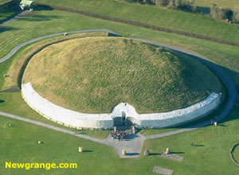
Newgrange was constructed over 5,000 years ago (about 3,200 B.C.), making it older than Stonehenge in England and the Great Pyramid of Giza in Egypt. Newgrange was built during the Neolithic or New Stone Age by a farming community that prospered on the rich lands of the Boyne Valley. Knowth and Dowth are similar mounds that together with Newgrange have been designated a World Heritage Site by UNESCO.
Archaeologists classified Newgrange as a passage tomb, however Newgrange is now recognised to be much more than a passage tomb. Ancient Temple is a more fitting classification, a place of astrological, spiritual, religious and ceremonial importance, much as present day cathedrals are places of prestige and worship where dignitaries may be laid to rest.
Newgrange is a large kidney shaped mound covering an area of over one acre, retained at the base by 97 kerbstones, some of which are richly decorated with megalithic art. The 19 metre long inner passage leads to a cruciform chamber with a corbelled roof. The amount of time and labour invested in construction of Newgrange suggests a well-organized society with specialised groups responsible for different aspects of construction.
Newgrange is part of a complex of monuments built along a bend of the River Boyne known collectively as Brú na Bóinne. The other two principal monuments are Knowth (the largest) and Dowth, but throughout the region there are as many as 35 smaller mounds.

Winter Solstice
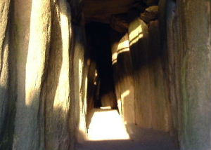
Newgrange is best known for the illumination of its passage and chamber by the winter solstice sun. Above the entrance to the passage at Newgrange there is a opening called a roof-box. This baffling orifice held a great surprise for those who unearthed it. Its purpose is to allow sunlight to penetrate the chamber on the shortest days of the year, around December 21, the winter solstice.
At dawn, from December 19th to 23rd, a narrow beam of light penetrates the roof-box and reaches the floor of the chamber, gradually extending to the rear of the chamber. As the sun rises higher, the beam widens within the chamber so that the whole room becomes dramatically illuminated. This event lasts for 17 minutes, beginning around 9am.
The accuracy of Newgrange as a time-telling device is remarkable when one considers that it was built 500 years before the Great Pyramids and more than 1,000 years before Stonehenge. The intent of its builders was undoubtedly to mark the beginning of the new year. In addition, it may have served as a powerful symbol of the victory of life over death.
Each year the winter solstice event attracts much attention at Newgrange. Many gather at the ancient tomb to wait for dawn, as people did 5,000 years ago. So great is the demand to be one of the few inside the chamber during the solstice that there is a free annual lottery (application forms are available at the Visitor Centre). Unfortunately, as with many Irish events that depend upon sunshine, if the skies are overcast, there is not much to be seen. Yet all agree that it is an extraordinary feeling to wait in the darkness, as people did so long ago, for the longest night of the year to end.

Newgrange Chamber
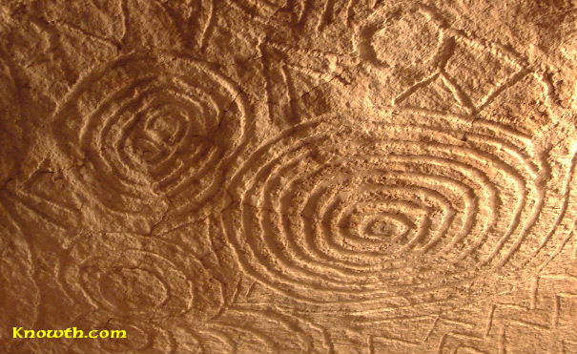
Amazing megalithic art carved on the underside of the roof stone in the east recess off the main chamber inside the mound at Newgrange.
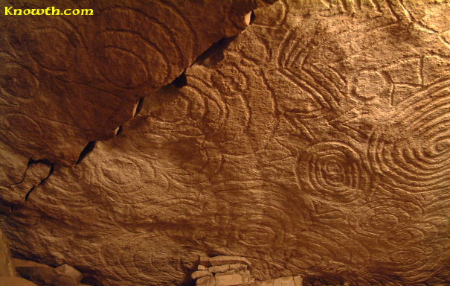
Another view of the megalithic art carved on the roof stone of the east recess off the main chamber inside the mound at Newgrange. Unfortunately the slab has cracked and two sections have moved slightly out of alignment.
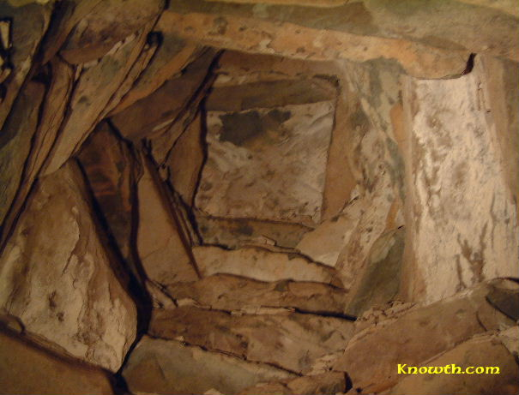
View of the corbelled roof over the chamber inside the mound at Newgrange,
the final roof slab is 12 ft (3.6m) above the floor.
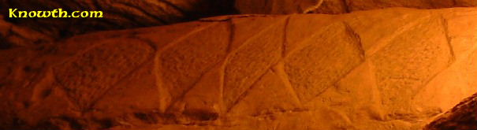
Lozenge design on the corbel beneath the roof stone of the
east recess is similar to the megalithic art at Fourknocks
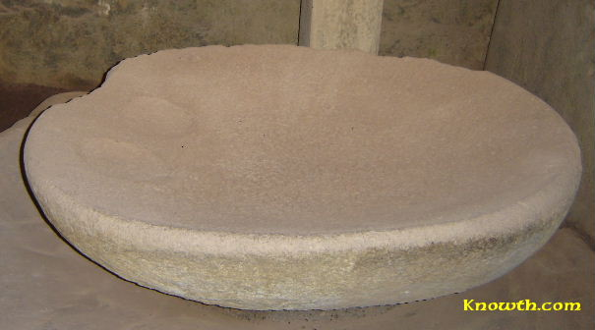
Stone basin in the right hand recess off the main chamber inside the mound at Newgrange
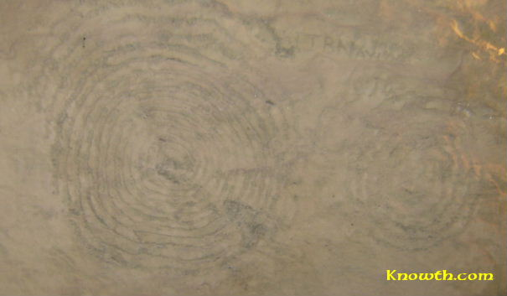
Spiral symbols at the back of the west recess off the main chamber.
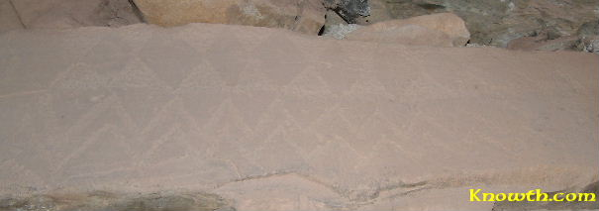
Corbel on the south side of the west recess, similar to the patterns at Fourknocks
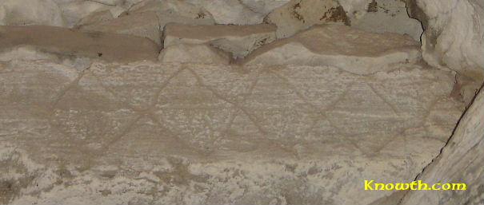
Roof slab over opening to passage from the chamber at Newgrange.
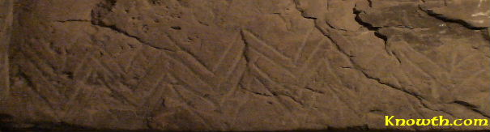
Corbel at back of east recess.
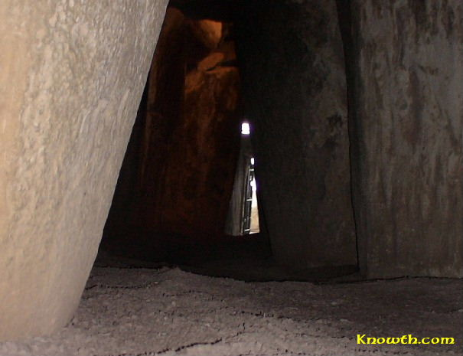
A view of the entrance from the floor of the chamber, the passage rises 6ft (2m)
from the entrance so that the roofbox is lined up with the chamber.
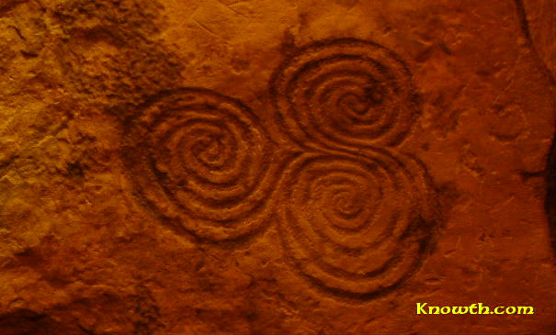

The tri-spiral design (above) on orthostat C10 in the north recess at the back of the chamber at New Grange is probably the most famous Irish Megalithic symbol.
The design is often called a triple spiral; however archaeologists call it the three-spiral stone.
The tri-spiral is often referred to as a Celtic design, however it was carved about 2500 years before the Celts reached Ireland.
The tri-spiral design is quite small in size at 30x28cm (12x11 inches) which is less than one-third the size of the similar design on the entrance stone.
This interesting symbol (left) from the side stone of the west recess looks like a representation of a fern or maybe a sheaf of wheat.

The tri-spiral design on orthostat C10 in the back recess of the chamber at New Grange is probably the most famous Irish Megalithic symbol.
The design is often called a triple spiral; however archaeologists call it the three-spiral stone.
The tri-spiral is often referred to as a Celtic design, however it was carved about 2500 years before the Celts reached Ireland.
The tri-spiral design is quite small in size at 30x28cm (12x11 inches) which is less than one-third the size of the similar design on the entrance stone.

Newgrange Plans
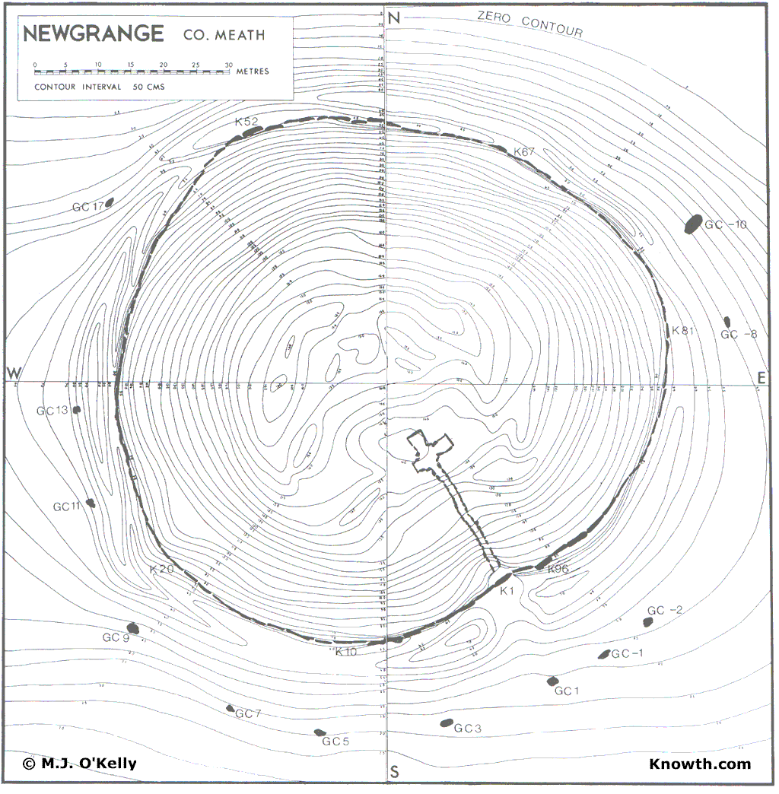
Plan of mound at Newgrange showing the passage and chamber.
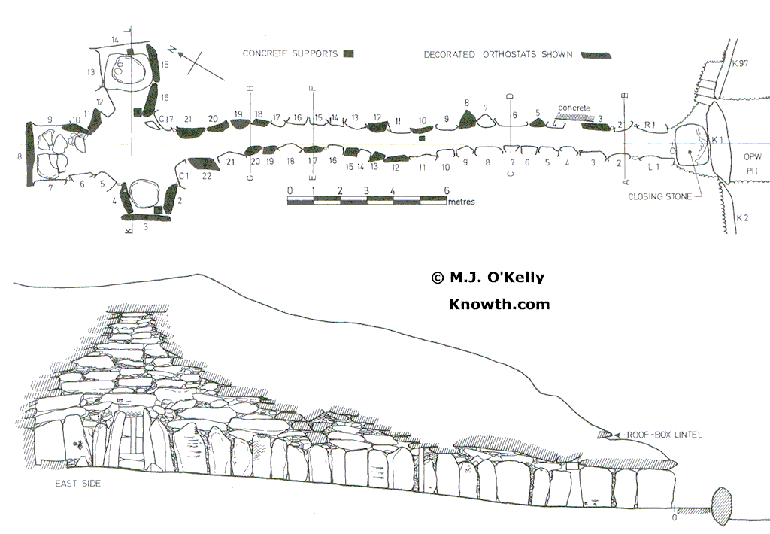
Plan and sectional elevation of the passage and chamber before excavation.
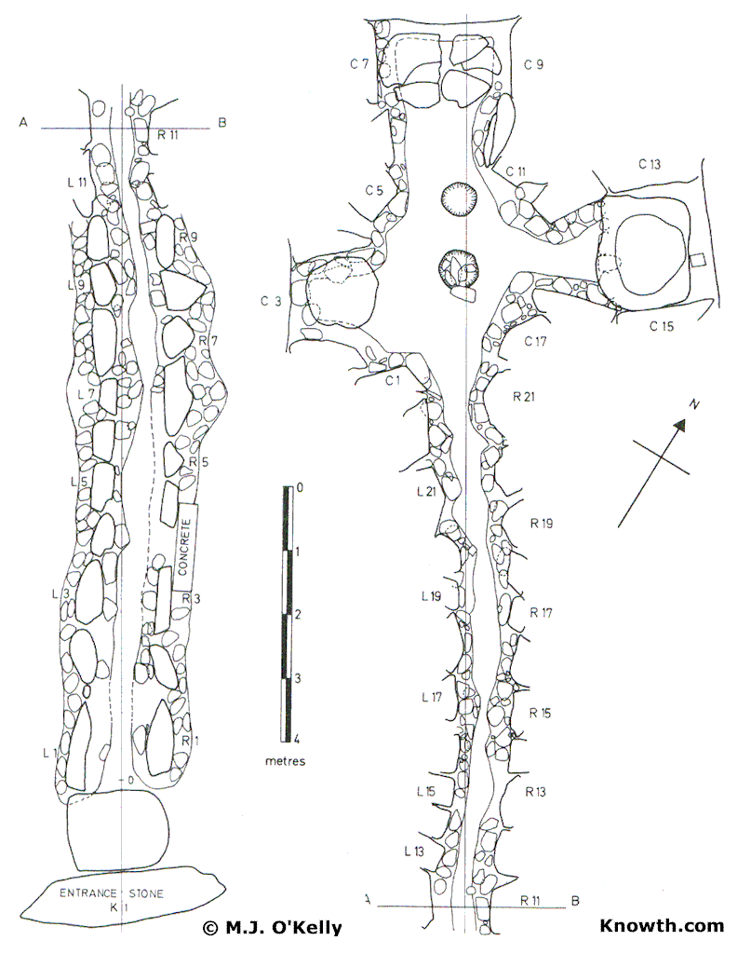
Plan of the passage and chamber, the passage is shown in 2 sections.
Newgrange is one of the finest examples, not only in Ireland, but in Western Europe, of the type of tomb known as a passage-grave. Its probable date of erection is about 3000 BC. It belongs to a time when stone, not metal, was the everyday material for tools and weapons. No metal has yet been found in a primary context in an Irish passage-grave.
The tomb consists, as the name passage-grave implies, of a passage and chamber, the walls and roof of which are built of large slabs without mortar. A large circular mound or cairn of stones covers the tomb and a kerb of massive slabs laid on their long edges, ends touching, surrounds the base of the cairn and was intended to act as a retaining feature. Surrounding the mound but situated from 7 to 17 metres outside it, is a circle of tall, widely-spaced standing-stones.

The Great Circle
This is the first feature encountered as one walks up the hill towards the monument. Only twelve standing-stones survive out of a possible original thirty-five or thereabouts. The four stones first seen are among the largest of those which remain and stand 2 to 2.5m above original ground level; many of the remaining stones have been broken off near the ground. None of the stones of the Circle is decorated. Newgrange Plans ...
The Circle is 103.6m (340 ft) in average diameter and encloses an area of about two acres. For those familiar with Stonehenge, it may be pointed out for comparative purposes that the outer bank of that monument is 320 ft (97.5m) in mean diameter. The two inner circles within the great circle at Avebury are each 340ft in diameter. There is of course no known relationship between these monuments and Newgrange.
The Mound
This is more properly called a cairn as it is made up of medium-sized water-rolled pebbles, 15 to 22cm across. White quartz stones were used as an outside finishing layer, at least in the entrance area. Quantities of these were collected during the excavations which took place between 1962 and 1975 and have now been restored to the outside of the mound. Round boulders of granite, about the size and shape of a child's football, rugby style, which were found with the quartz, must also have been employed as a finish and they can be seen today interspersed with the quartz in the revetment wall. The theory has frequently been adduced that they were used as mauls to dress the slabs but it is clear that this was not their purpose.
At present the cairn is about 11m (36ft) high, taking its vertical height from original ground level just outside the Entrance Stone. Since the cairn is set on the highest point of a ridge of ground it appears higher than it is, especially when seen from a distance. Newgrange Plans ...
The Kerb
A continuous girdle of large slabs surrounds the base of the cairn. With the passage of time, this had collapsed downward over the kerb so that the latter had become hidden. Previous to the excavations only three kerbstones were left fully exposed, the Entrance Stone directly outside the mouth of the passage, Kerbstone 52 diametrically opposite the Entrance Stone on the north side of the mound, and Kerbstone 67 to the east. Twenty-one stones are now fully exposed to the left of the entrance and eighteen to the right, while a further eight can be seen at the back of the mound. This enables one to get a good idea of what the monument must have looked like when newly built. Many of these newly-exposed kerbstones are decorated but the three first-mentioned are by far the most striking. Only the tops of the remainder are uncovered, as one can see if one makes a circuit of the mound.
The kerbstones vary in length, the smallest being about 1.7m long while the largest is 4.5m. Those in the entrance area are between 3 and 4m in length and average about 1.2m in height above original ground level. The diameter of the kerb (and mound) varies between 79m (260ft) NW-SE and 85m (280ft) NE-SW. It encloses an area of just over one acre. To compare with Stonehenge once again, the diameter of the circle of Aubrey Holes inside the great bank already mentioned at that monument is 288ft (87.8m). These comparisons are drawn solely to give a touchstone for size to those familiar with the English monuments. Newgrange Plans ...
The Roof-Box
Before dealing with the tomb proper a structure must be mentioned which rests on the front part of the passage roof about 2.4m back from the entrance to the passage. Before the cairn material was removed from this part of the roof in 1963 so that the orthostats (standing-stones) in the passage beneath could be straightened up, all that could be seen of this structure was the decorated front edge of its roofstone. As soon as the cairn material was removed the structure was discovered buried underneath it but quite intact except for a certain amount of subsidence at its north and east sides. The decorated edge of the roofstone first came to light, according to W. R. Wilde, a few years previous to his first visit to Newgrange in 1837 and from then on it was to be seen protruding through the cairn above the entrance. Indeed its continued preservation was little short of miraculous since one Richard Burchett described to the Society of Antiquaries in London in 1874 how he 'uncovered its whole surface, but found two men with crowbars incapable of moving it without greater risk to its safety than I was willing to incur'. He went on to say that 'its mysteries therefore remained unsolved'.
Up to 1963 when the cairn was removed from about it the existence of the structure beneath was not even suspected. The name 'False Lintel' was applied to the decorated roofstone as it was believed to be no more than a relieving lintel for the passage entrance.
The roof-box, as the structure is now called, is situated over a small gap, 20 to 25cm wide, between the first two roofslabs of the passage. It is through this slit that the rays of the rising sun penetrate to the chamber at the time of the midwinter solstice (pi. 4). The roof-box is 90cm high, lm wide, and 1.2m from front to back.
The Passage
The entrance to the tomb is in the south-east of the mound but for ease of description it will be referred to as the south; thus, the passage will be said to run south to north and the sides of the passage to left and right will be the west and east sides respectively. The tomb chamber is entered through a long passage lined on each side with standing-stones; there are 22 on the left-hand (west) side and 21 on the right (east). They average 1.5m in height above present ground level but there is considerable variation among individual slabs, those nearest the chamber are the tallest, being almost 2m high.
The first part of the passage is roofed by three large slabs which rest either on the tops of the orthostats at each side of the passage or on slabs (corbels) resting on the orthostats; the roof-box is situated over the gap between the first and second of these roofslabs. After this first more or less horizontal stretch, the roof is corbelled, that is, the slabs are set one on another so that each one rests partly on the roofslab beneath it and partly oversails it so that a gradual rise in height is achieved. Seen from the passage below, a straight run of corbelling such as this resembles somewhat the underside of a stairs. There are 17 roofslabs in all in the passage as viewed from below.
The combined length of passage and chamber is 24m (79ft); it can be seen, therefore, that the tomb occupies only about one-third of the total diameter of the mound. The passage is 18.9m (62ft) long and about lm wide. The height, as we have seen, varies; the first part is from 1.5 to 2m high but as the corbelling rises, so does the height until the last roofslab, RS 17, is 3.6m above the floor. The forward edge of this slab when viewed from the chamber can be seen to have a pattern of four divided lozenges carved on it.
The large slab now set upright to the right of the passage mouth was used by the tomb-builders to block the passage entrance when the monument was finished. Many of the passage orthostats are ornamented and all are dressed. Both ornament and dressing were done by making a series of small, closely-spaced pits or pickings in the surface of the slab, using a hammer and a pointed implement, presumably of flint. Visitors will observe many variations in the picking techniques used. Newgrange Plans ...
The Chamber
Three side-chambers or recesses open out of the main chamber to left (west), right (east) and straight-ahead (end or north), so that on plan the whole tomb has the shape of a cross with a very elongated shaft, the passage being the shaft and the three recesses the arms and head. It need hardly be emphasised that this cross or cruciform shape has no connection with Christianity as Newgrange was built more than three thousand years before the birth of Christ.
It will be noticed that there are only four orthostats, strictly speaking, in the main chamber; the others constitute the sides and backs of the recesses. The east recess is the most lavishly decorated. The chamber is 5.2m (17ft) long from its entrance to the back of the end recess and 6.5m (21ft 6in) wide from the back of the west recess to the back of the east recess. It is 6m (20ft) high at its centre point. The recesses are between 2.4 and 2.8m high.
The corbelled vault of the chamber is one of the finest of its kind in Western Europe today, standing intact without conservation or repair of any kind exactly as it did when first erected 5000 years ago. It is constructed of horizontally-laid courses of large slabs, each course partly resting on the one below it and partly oversailing it so that with each course the diameter of the roof diminishes, until finally the vault is closed by a single capstone six metres above the floor. The outer ends of the corbels are buried in the cairn and are tilted slightly downward; this serves to throw off the rainwater percolating through the cairn. That it was a most effective weather-proofing is well demonstrated because the chamber remained dry even in prolonged bad weather except in a few spots, now cured. Newgrange Plans ...
Basin Stones
Large chiselled stones to which the name basin stone is given occupy the floors of the recesses. They are a feature of some Irish passage-graves. Those who have visited Dowth and Loughcrew will be familiar with the basins there. There are four at Newgrange: one in the west recess; a broken, incomplete one in the north recess; and two in the east recess, one standing inside the other. The upper of these two (pi. 6) is particularly well-shaped and is of granite in contrast to the others which are of sandstone and slate. One of the finest examples yet found is in the eastern recess of one of the recently opened Knowth tombs - Knowth East.
The basin stones would have contained the bones - either unburnt or burnt, or both - of those for whom the tomb was built. With them would have been placed funeral offerings of pottery, bone pins, stone balls and pendants, stone and bone beads, and perhaps flint arrowheads. It is not to be expected that these would have survived intact in the Newgrange basin stones since the tomb chamber has been accessible for more than two hundred years. Nonetheless, when the floor of the chamber was excavated in 1967 a small quantity of human bone was recovered together with some typical grave-goods such as pendants, balls or 'marbles' and fragments of bone pins, sufficient at any rate to show that the tomb was used for burial and was not, as has been suggested, a cenotaph or a temple.
The basin stone in the west recess is almost rectangular, measuring 1.2m by 90cm; the interior is flat and there is a very slight lip for about two-thirds of the perimeter. That in the north recess is in several fragments but a basin of about 1.2 by 1.8m is suggested; there is a very slight lip on one fragment. The upper of the two basin stones (pi. 6) in the east recess is chiselled all over, both inside and out. Note the two circular depressions 20 and 45cm respectively in diameter, which are sunk close together just below the inside of the rim. Their purpose is not known. This basin is almost circular, having a rim-diameter varying from lm to 1.2m. The lower basin is a good deal larger and is also a splendid specimen; it is rectangular in shape, measuring 1.8 by 1.2m.
The Builders of the Tomb
A tomb such as Newgrange would lead one to suppose that it must have been destined as the final resting-place of a leading or kingly family (passage-graves were collective tombs) but in the absence of the kind of evidence that has proved so informative in other lands, notably in Egypt, we can only speculate about the matter.
Many visitors will be familiar with the ancient tales which relate that the kings of Tara were buried at Newgrange. It is called Bru or Brug na B6inne in these accounts. The tale is told that Cormac mac Airt, one of the most famous of the Tara kings, did not wish to be buried at the Bru because it was 'a cemetery of idolators', but in spite of this his servants tried to take his body there. The river Boyne however, 'swelled up thrice, so as that they could not come' and the pious Cormac was buried at Ros na Righ across the river after all.
Another body of ancient tales associates the Bru with Oengus, one of the Tuatha De Danann, a legendary pre-Celtic race. Oengus was known as Oengus an Broga and the Bru was often called the House of Oengus. Once again, many visitors will know the story in the Fionn Cycle which in translation is called 'The Pursuit of Diarmaid and Grainne'. In this, Oengus watches over the lovers, rescues the lady when Diarmaid is hard-pressed by his enemies, and finally, when the hero has died through a knavish trick of his rival, Oengus brings Diarmaid's body back to the Bru for safe-keeping.
Alas, these are but tales. Newgrange was already several thousand years old when the kings of Tara ruled. We do not know who built the Boyne tombs nor who were interred in them. There are more than 200 passage-graves in Ireland at present and there were originally more. It is generally thought that the practice of building passage-graves came to Ireland from Brittany, nevertheless, as far as the actual people who built them are concerned, very little more is known about the Boyne tombs now than in the days when they were attributed to the kings of Tara or to the Tuatha De Danann.
Other Features
Towards the eastern boundary of the Newgrange enclosure visitors will notice settings of concrete posts and slabs. Two separate features are involved. The one nearer the kerb of Newgrange consists of a series of concrete uprights which mark the centre points of large deep pits which had been dug in three parallel arcs. The continuation of these arcs runs out of the excavated area at each side, i.e., to south and east. If the rows of pits formed complete circles, the centre point would be somewhere in the field outside the Newgrange enclosure on the east. They would not therefore have been concentric either with the kerb of the main mound or with the Great Circle. Furthermore, the curvature is too great for the arcs to bear any relationship to Site Z nearby.
The pits averaged 1 to 1.5m in mean diameter and about 1 to 1.25m in depth, though individual pits were in some cases up to 2m deep. All were emptied in the course of the excavations and apart from animal bones and flints, no clues were obtained regarding their purpose or their date. All that could safely be said was that they were filled up before the cairn began to collapse and before the beaker people arrived. In the case of one of the pits, a beaker hearth had been built over the filled-up pit.
The other feature is the satellite passage-grave, Site Z, which was discovered during the excavations. It had been almost totally destroyed in the past, presumably in order to facilitate tillage. Those of the orthostats which were recovered intact have been re-erected in their former positions; only the sockets of the remainder were found and the positions of these are marked by concrete slabs. The plan of the grave and of part of the kerb may thus be traced. The remainder of the mound lay outside the enclosure and was not excavated. The quartz found during the excavation is piled up in one part of the site.
A curious little stone structure can be seen on the down-hill slope behind the Newgrange mound to the north-east. It was built from the stones which had slipped off the cairn in the past and which lay scattered roundabout. It is presumed to be one of the 'follies' beloved of landlords in a more spacious age.
As one enters the Newgrange enclosure from the road, a standing-stone can be seen on one's left hand. This was originally lying in a drain in the townland of Dowth close to Site H but it was removed to its present position in recent years for safe keeping. It is ornamented on two faces.

http://www.newgrange.com/
http://www.voicesfromthedawn.com/newgrange/

