Divisibility Rules
- Which numbers are divisible by 4? By 8? By 10? How do you know?
  - 212 c. 512 e. 5450
  - 380 d. 2132 f. 12 256
- Use the digits 0 to 9. Replace the __ in each number to make the number divisible by 4.
  - 822__
  - 211 4__8
  - 12 __32
Patterns and Relationships in Tables
- Find the output for each table
Input (n) | Output (3n + 4)
1
2
3
4
Input (n) | Output (4n + 3)
1
2
3
4

- Find the relation for each input/output table
Input | Output
1 | 5
2 | 8
3 | 11
4 | 14
Input | Output
1 | 8
2 | 13
3 | 18
4 | 23

Graphing Relations
- 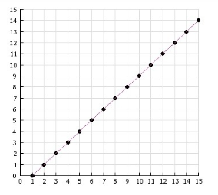
  - Label the graph with ‘input’ and ‘output’
  - What is the output when the input is 1?
  - Which input gives an output of 6?
  - If you extend the graph, what would the output be if the input is 20?

