Writing from Home:
We would love to read what you are writing. Email or send a picture. We miss all of you.
Choose any of the following (if choosing a picture you may write a story, describe the picture, or respond with any thoughts or feeling it creates)
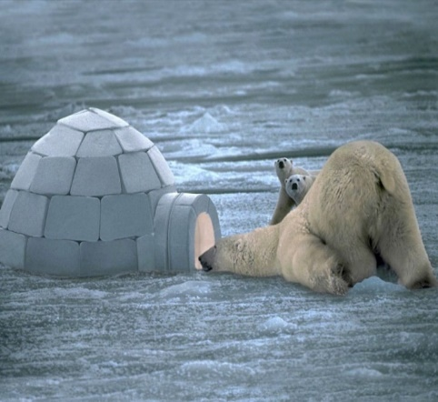 | HOW DO YOU DO  Write a “How To...” presentation. Explain how to complete a task that you know how to do. You can write step-by-step instructions in your scribbler or in a PowerPoint, or prepare a script and do a demonstration video. Some examples: how to draw a well-known Disney or Marvel character, how to scramble eggs, how to make a bed, etc… | CELEBRATION TIME  Write a story that begins with:  The bells rang and the celebrations began! I couldn’t wait to…
PROBLEM SOLVER  What is a problem you would like to solve? Explain how you would do that in a video or in writing. Think about the causes for this problem, who it is affecting, what materials you might need to use to solve this, where the materials would come from, who you might get to help you, how long it might take to do this. | DEAR TEACHER  Write a letter to me, explaining what you have been doing, what you miss doing, and what you plan to do soon. | 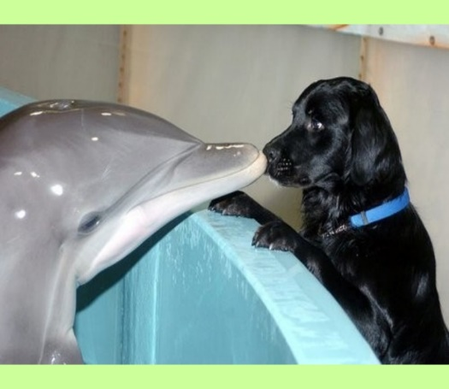
STRANGE HAPPENINGS  Write a story that begins with:  I woke up this morning in my backyard and I don’t know how I got there! | 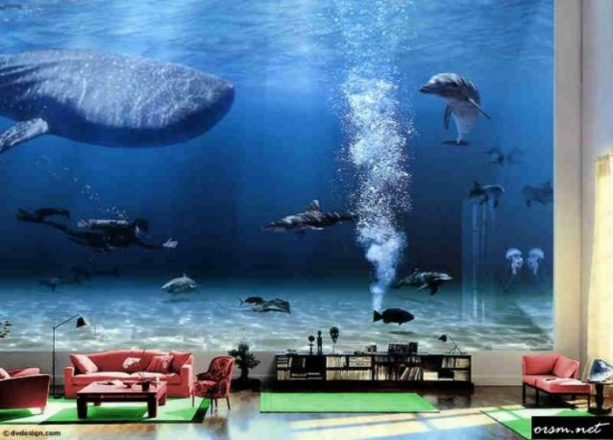 | FEAR FIGHTER  Write about a time when you felt afraid. How did you get through that time?

You can write about any topic of your choice, fiction (made-up) or non-fiction (true), that is interesting to you.

