Grade 8 Persuasive Essay Workbook – April 20th- 27th Name:

Purpose of the Unit:
- One of the key skills that students will need in high school is persuasive writing. Our plan was to teach this unit after March Break. Although students have had exposure to persuasive writing every year, there are some other elements that were to be introduced in grade eight. By following this unit, you will enhance your skills and readiness levels. I have broken down the unit into weekly sections, much like I would in class. I have also included PowerPoint slideshows similar to what I would use in class. Remember that through your student email, all students have access to Office 365, which means that you have free access to Microsoft Word and PowerPoint. These can be used as Apps on your phone/tablet or on a computer. That means that all of you are able to access the teaching slides.

- I would like to help students and offer them feedback during this process. I can be contacted at krista.hutchsion@nbed.nb.ca. Students may contact me by email or through the chat function on the Teams Site (you have all been added to a Teams Site through your student email, if you so choose to use it).

Sequence of the Unit:
April 20th-27th:
- What is a persuasive essay? It is important to start by investigating what good essays look like. You have all practiced “reading like writers” during our narrative unit in the fall. Now you will apply these skills to persuasive texts. Once you have a grasp of what an effective persuasive essay looks like, you will begin the process of writing your own persuasive essay.
April 27th – May 4th:
- Choosing a topic. You will work on narrowing down a topic that is of interest to you.
- Collecting Information. You will learn about research strategies, particularly regarding online sources. You will find three sources of information on your topic.
- Prewriting. After you have your information, you will use a position/support web for the preliminary organization of your information.
May 4th-11th:
- Writing an Introduction. You will explore different types of leads, the elements of an introduction, and then you will write your own introduction.
- Writing the Thesis Statement. You will learn how to write a sentence that states your opinion on the topic.
- How to Avoid Plagairism. In this section, you will learn how to avoid plagiarism in your writing. This includes how to incorporate quotes and put research into your own words.
May 11th-18th:
- Writing the Body. You will learn how to organize the body and supporting arguments and details. Then you will complete a draft of your body.
May 18th – 25th:
- Conclusion. You will learn how to write an effective conclusion.
- Revising and Editing the Rough Copy. You will complete a checklist for revising and editing your essay.
May 25th- June 1st:
- The Final Draft. You will complete a final copy of your essay.

What is a persuasive essay?
  - A persuasive essay is a piece of writing that argues for or against a position on a given issue using supporting evidence and persuasive techniques.

Let’s start by “reading like writers”; by investigating what some professional writers are doing in their persuasive writing pieces.

- Rick Reilly:
- Mentor Text: Rick Reilly - "Keep Skeleton in the Closet“ (Rick Reilly is a famous sports writer known for infusing humour into this persuasive writing pieces. I thought it would be fun for you to see how a unique writer such as Reilly, writes his persuasive pieces. The hard copy is available in this booklet and a link to the online article is available on my Teacher Page and the Teams Site.

- Your Task: Read the article and notice how the author uses the following traits of writing. You may write or type what you notice directly in this booklet in the spaces below:

- voice

- conventional artistry (using punctuation, spelling, etc. in a creative way for effect)

- creative sentence structure (mixing up sentence lengths for effect)

- argument (Where do you notice the author's opinion?)

Keep Skeleton In the Closet

There's no strategy, no passing anybody. No getting air, no doing flips, no Dick Button. Nothing. Just get on the slab of metal and point it downhill.

People do dumb things. Ride grocery carts on I-­‐95. Pet porcupines. I once saw a guy in Vancouver light his beard on fire for $2.

But at least they never made a Winter Olympic sport out of those.

You can't say that for skeleton, which is not just the dumbest Winter Olympic event ever invented, but it also might be the dumbest sport ever invented.

And I'm including lawn darts.

In skeleton, people dress in rubber suits, lie on a glorified lunch tray and slide down a hill.

That's it. There's no strategy, no passing anybody. No getting air, no doing flips, no Dick Button. Nothing. Get on the slab of metal and point it downhill.

And yet for the next month NBC is going to make this sport seem like it's the equivalent of saving cafeterias full of kidnapped third-­‐graders. Bob Costas is going to sit there with a straight face and tell you, "In this next report we'll tell you how one skeletoner bravely slides despite a pretty big strawberry on her elbow!"

But that's not the stupidest thing. The stupidest thing is that all across America, people will actually care! They'll stand around the company coffee pot going, "Man, did you see that ol' boy win skeleton? Made you proud to be an American, dinnit?"

No! This sport is about as Olympian as dwarf tossing! It just happened to find an unlocked back door into the Games. Most of its competitors didn't even take up the stupid sport until last Thursday. For instance, there's 2004 national champ Eric Bernotas. He discovered skeleton in 2001 when he and his former girlfriend took a spur-­‐of-­‐the-­‐ moment detour to the Lake Placid track while they were on their way to Vermont.

Wilford Brimley could've been on the team if he'd have thought of it.

Do you know how many people skeleton in the United States-­‐-­‐at any level, including beginners? "I'd say about 100," says U.S. Olympic skeleton spokesman Tom LaDue. "Maybe 200."

Whoooo-­‐eee! Skeleton Fever: Catch it!

What's next? Pizza-­‐box sliding? Synchronized frostbite?

How did they even get skeleton back in the Olympics, after it was rightly dumped in 1948? It was rediscovered by thrill-­‐seekers in the early 1980s, and pretty soon they were pushing for it to be in the Olympics again. And since the Winter Olympics are stretched thinner than Joan Rivers's neck-­‐-­‐there are enough real sports for seven days, but the Games go 17-­‐-­‐the IOC bought it. Probably because it's such a cheap sport to run.

"You use the same venue as the bobsled, same stands, same cameras, everything's already there," says Jim Shea Jr., a onetime bobsledder who was part of the movement to get the sport reinstated for the Salt Lake City Games in 2002.

And do you know who was the best male skeletoner in the USA back in 2002? That's right, Jim Shea Jr.! And do you know how he'd gotten to be the best male skeletoner? He was working as a bartender, "saw some jackass doing it," he admits, and thought he'd try it. The only trick is to hang on when you hit 80 miles per hour. You need a strong grip and weak brains.

Next thing you know, Shea's reading the athletic oath at the Opening Ceremonies in front of four billion people! Holding the torch! Visiting Bush at the White House! I mean, it was almost like people thought he was a serious athlete!

Anyway, this bunch of lucky stiffs somehow got invited to the debutante ball, and now they're bathing in the punch bowl. So far, the U.S. skeleton team has ... 1) suspended its coach, Tim Nardiello, because two female skeletonesses have accused him of sexual misconduct; 2) seen one of its best (cough-­‐cough) athletes, Noelle Pikus-­‐Pace, break her leg after falling from a platform near the bobsled track that got hit by-­‐-­‐guess what?-­‐-­‐a bobsled; and 3) watched one skeletoner, Zach Lund, test positive for a substance which can be used to mask performance enhancing drugs.

And your first reaction is, Dude, you're sliding on a frickin' cake pan! How much performance enhancing do you need? But then you find out that Lund claims the drug was from a baldness treatment he was taking. Poor guy. In one story people found out two embarrassing things about him: 1) He's balding; 2) he skeletons.

So I've decided I'm going to invent my own sport-­‐-­‐using a venue that already exists-­‐-­‐and win myself a gold medal.

"Man, did you see that ol' boy win the Zamboni jump? Made you proud to be an American, dinnit?"

Closing thinking question: How is this persuasive piece different than those you have read and written in the past?

Important take aways from Rick Reilly’s article:

- Let your personality come through in your writing.
- Don’t be afraid to use humour and sarcasm if it suits the topic.
- Be creative with your sentence structure and use of conventions.
- All of these are persuasive techniques that Rick Reilly uses to convince his audience to agree with his point of view!

To prove my point, check out what Rick Reilly’s essay would look like without voice and creativity…

SKELETON SHOULD NOT BE A WINTER OLYMPIC SPORT
BY LITERALLY ANYONE

Not every activity can be considered a sport, much less a sport deserving a place in the Winter Olympics. This is especially true of skeleton.

In skeleton, people ride a small sled down a frozen track while lying face down and head-first. Although it receives the same attention as any other sport at the Winter Olympics, it does not involve the same level of strategy, skill, or artistry required by other sports.
Skeleton’s competitors do not need to train as much as those of other sports: for example, national skeleton champion Eric Bernotas only discovered the sport by chance three years prior to his 2004 win.

Not many people even compete in skeleton at any level, including beginners. U.S. Olympic skeleton spokesman Tom LaDue estimates that there are only 100 to 200 competitors in the United States.

Although it was rightly removed from the Winter Olympics in 1948, skeleton was reinstated for the Salt Lake City Games in 2002. This was for two reasons: 1) the IOC needs content to fill the 17 days that the Games last; 2) it’s a cheap sport to run, since it only requires the same venue, stands, and cameras that are already required for bobsledding.

Jim Shea Jr. (a member of the movement to reinstate skeleton at the Winter Olympics) was the best male skeleton competitor in the USA in 2002, and so was given all the privileges that come with being a star athlete: reading the athletic oath at the Opening Ceremonies in front of four billion people; holding the torch; and visiting President Bush at the White House. He himself, however, admits that he only got into skeleton on a whim, and that it hardly requires much skill or technique.

The U.S. skeleton team’s track record has not been remarkable enough to justify its inclusion in the Olympics. To date, its only newsworthy events have been: 1) the suspension of its coach, Tim Nardiello, after two female skeleton competitors accused him of sexual misconduct; 2) one of its best athletes, Noelle Pikus-Pace, breaking her leg after falling from a platform near the bobsled track; and 3) competitor Zach Lund’s positive test for a substance which can be used to mask performance enhancing drugs.

Given all of this, it is clear that skeleton should not be a Winter Olympic sport.

#snoozefest

Comparing Writers’ Styles:
- So if Rick Reilly’s persuasive techniques are to use humour and sarcasm to draw the reader in, what are other writers doing? I mean, not everyone is funny. Let’s take a look at Mitch Albom, another prize-winning sports writer. He likes to get creative with his sentence structure and conventions, just like Reilly, and he likes to use his voice to persuade the audience. BUT, rather than appealing to the audience’s sense of humour, he appeals to their heartstrings, their emotions, their…sensitive sides. Take a look…

A Senseless Death in Our Age of Anger
By Mitch Albom Published: 12/29/1991

He was running from them now, a teenager running from other teenagers, and he felt the terror you feel in dreams when someone is gaining on you and you can't get away. His friends were running ahead of him, and they made it to the car and dived inside and locked the doors but he kept running, the way he used to run down a lacrosse field, heart pumping, legs churning. He ran to the front of the school but the others caught him, tripped him, pushed him to the ground. They were around him now and they began to kick. One to the stomach. One to the head. Another to the head. Maybe he tried to say something like "No" or "Please," but you wouldn't have known it because he was sucking air by this point, gasping, and they were all too young to understand that the life had begun to ooze out of him. Another head kick. Another.

It was Friday night, teenagers doing another teenager, but this was not inner-city violence, this was not about money or drugs or a new coat, this was about nothing, a fight after a dance, suburban macho, some of the kids barely knew who they were kicking! And they kicked him again. Eight times. Nine times. Now he was on his hands and knees, halfway into blackness, and the kid who had at least partly started all this, the skinny teenager from the initial fight that was supposed to be one-on-one, came staggering up from behind, his eye bleeding, and he stood over his fallen rival and allegedly said, "This is for breaking my gold chain." And he kicked him in the face.

Alex Stachura never got up again. He was rushed to the hospital. His parents were called. As they drove to the hospital, they thought "auto accident" because that's what you think when you live in the suburbs and you get a call from the hospital, right? Auto accident? You never figure your 16- year-old boy got his head kicked in.

"There'll be an operation," his mother told herself in the waiting room.
"He'll be sick, but I'll nurse him, I can do it, I am his moth--"

The doctor came out.

Alex was dead.

This is a story about how violent we have become, even our most pleasant neighborhoods, and how this all has to stop, this teenage fury, because it's so damn senseless. They act tough, they talk tough, but they have no idea what their bodies can do -- and soon we have one more mother's son buried in the earth, and four others facing a second-degree murder charge.

"They're just kids," you want to say.

Yes. They are. Grab and roll.

"This is Alex," says Walter Stachura, sliding a high school yearbook across the table. He is sitting in the kitchen of his home, the same place he was sitting that night when the phone rang. Across from him sits his wife, Alicia, who is biting her lip and dabbing her red eyes, because this is the first time she has talked about her son's death with a reporter. In between is their 14-year-old daughter, Colleen, and their eldest child, Jason, a college freshman whose blond hair and pout give strong resemblance to his dead brother. Both boys played lacrosse at Warren De La Salle High School, and the yearbook photo shows Alex running down a field, stick in hand. He earned a junior varsity letter in the sport, and once bragged about a game in which he scored two goals and checked his opponent really hard. So he was not afraid of contact, but fighting was not his thing. He had a quick wit, he could cut you up verbally. He didn't need to throw punches. But someone else did.

"These boys who fought Alex. Some of them had called and threatened him before," his mother says. "Once they got Jason on the phone by mistake and threatened him."

"It was your typical teenage stuff," Jason says. "They said, 'We're gonna come beat your head in.' "

On the final night of his life, Alex Stachura knew he would fight. He knew where. He knew the opponent. A kid named Nicholas Del Greco, who used to attend De La Salle but had transferred that semester to Sterling Heights High School, had been stirring a feud with Alex since last spring. It began over a girl, but the girl was now history, yet the anger lingered. Why? Who knows? Why do teenagers stay mad over anything?

On more than one occasion, Alex tried to stay clear of Nick. Once, according to the Stachuras, Nick and his buddies even pursued Alex in a high-speed car chase. Alex got away. By autumn, things had come to a head: Without the parents knowing it, Alex and Nick agreed to fight Sept. 20 after the dance. Alex reportedly told a friend, "I'm going to get my ass kicked tonight." He went anyhow. Because of that, he is not blameless. But in this story, nobody is.

They met behind an elementary school. Alex came in a car with three friends. Nick arrived in a four-car entourage, maybe a dozen kids. A judge would call them "a gang," but truth is, many barely knew Del Greco or Stachura. They came to watch, which is even more sick.

What happens next depends on your witness. Most agree the two boys traded punches, then began a grab-and-roll on the asphalt. After a few minutes, Alex had clearly won the scuffle, and they disengaged. There was yelling. Alex began to walk away, he may have screamed at the crowd, and Nick hollered something like "Get him!" and then Alex began to run. And suddenly, the group, these children, took on the bloodthirsty coloration of the moment, and they began to chase him, kick him . . .

Cause of death was head injuries, swelling of the brain. Witnesses suggest Alex was kicked 11 to 15 times by the four Sterling Heights students who were arrested and charged: Del Greco, 16; Matthew Trout, 16; Arthur Zrodlo, 15, and Marek Sobotka, 17. The prosecutor asked for second-degree murder charges -- he said you kick someone in the head, you know what you're doing -- and another thing: He wanted them tried as adults, not juveniles. The judge agreed.
So now the four teenagers, if convicted, could be sentenced to life in prison.

In the meantime, three of them are back in high school.

"They're just kids," you say . . .
'So horribly final'.

Inside the Stachura home, upstairs in Alex's room, the bed is neatly made, as if he might be home soon. His lacrosse stick stands in the corner, and a picture of him in his lacrosse uniform sits atop the bureau. There is a Bible on the desk, with his doodles on the edge of the pages. One of them reads: "You can die before you get old, but me, I'm gonna live forever."
Sixteen years is not forever. And Alex is never coming home. Downstairs, the house is quiet, save for the hum of the refrigerator and the sound of a mother crying into a tissue.

After Alex was pronounced dead at Macomb Hospital Center, the very hospital where he was born, Alicia and Walter were permitted a few minutes with the body. A nurse said, "Be quick." Walter pushed aside the curtain and saw his son on a gurney, a tube still stuck in his mouth, the red blotches on his chest where they had tried to revive him.

Alicia leaned over to kiss Alex, and his skin was cold. "I kept remembering how he liked to stay in bed in the morning," she whispers now, her eyes beginning to crumble in tears. "You kind of had to wiggle him out . . . and . . . I used to wake him up by kissing him and . . . I would kiss him and he was always so warm, so warm and now he was so cold and oh, this is .. . so final! So horribly final!"

She is trembling, squeezing her eyes shut. Her husband begins to cry with her. "They keep saying it gets easier," Alicia says, "but it . . . it doesn'tget easier. Every day Alex gets further and further away. . . ." It's time to change.

Where is the lesson in all this? By all accounts, Alex Stachura was a good kid -- not a saint, but a responsible young man who helped out at his church and worked summer jobs and liked music and had friends. And the others were supposedly good kids, too. Played on the sports teams, played in the band. No previous crimes.

So how could this happen, that their lives and families are now soaked by this bloodshed? For what? Teenage pride? Outside of Del Greco, the others barely knew Alex. How could someone do this to a stranger? Kick him in the head? Allow others to do so? What kind of children are we raising? Do they think it's not real? Is it all those violent movies we let them watch -- Chuck Norris, Steven Seagal? Is it sports, from football to pro wrestling?

Or is it simply the age we live in -- an age of anger and blaming others and feeling good when we flatten someone? A recent poll was conducted among Macomb County students. They said their top problem is no longer drugs or alcohol. It is "student conflict." Kids making war on other kids.

What does that tell you?

Not long before he died, Alex Stachura wrote a composition about God. These are his words:
"I believe God is different things at different times in your life. Right now, I think God is a stand-up comedian trying out his act on the human race."

How sad a world we give to our young. The new year is upon us, and if you make no other resolution, make this one: to spend more time with your children, deal with their anger, teach them peace, before we have another Alex Stachura story, one dead, four arrested.

"They're just kids," you say.

Not anymore.

Your task – please read like a writer and note anything that you noticed about Albom’s style in the following areas:
  - Voice (where does Albom appeal to emotion):

  - Creative sentence structure:

  - Conventional Artistry:

  - What is his argument/opinion?:

What should your persuasive essay look like?

- Now that we’ve checked out some interesting choices that professional writers are making in their work, let’s look at the specifics of what a strong grade 8 persuasive essay looks like.

- Your task: Read the mentor text essay, “Bike Lanes” and make notes on the following:

- What do you notice about how the essay is organized?
2. What types of evidence does the student use to support his/her opinion?

3. What persuasive strategies does the student use?

4. What are some things that you don’t understand?

Wild Side to the Safe Side
You hold a firm grip on your handle bars heading alongside the rushing traffic. A car honks its horn as it carelessly races past you. You gasp in fear almost falling off your bike. Your heart beats faster than the wings of a hummingbird. The glossy, vibrant, red car swerves dangerously close to you. Your muscles tense up and a surge of panic washes through you. Is this really worth the risk? Should I just drive my car to work instead? With bike lanes you wouldn’t need to worry about the cars zooming by and all the reckless drivers. Bike lanes promote cycling and cycling has plenty of health benefits. They make the road a safer place and reduce the number of cars on the road.
What’s the hold up? The price? Although bike lanes may be costly to install, they will save the city money in the long run on health care costs because cycling has so many health benefits. For instance, cycling protects people from diseases such as cardiovascular disease. Cardiovascular diseases include stroke, high blood pressure and heart attacks. Research has shown that if you cycle, the chances of bowel cancer is reduced. Cardiovascular disease and cancer alone cost the Canadian health care system over $25 billion per year. Dr. David Nieman said, “People can knock down sick days by about 40 percent by exercising aerobically on most days of the week while at the same time receiving many other exercise-related benefits.” Also, cycling reduces anxiety and depression. In addition, it improves strength, balance and coordination. So, if you are that clumsy friend who always seems to bump into everything – you might want to consider cycling.
Climate change is a huge problem worldwide. Unfortunately, Canada’s temperature is rising faster than the global average. That means change is required because the smallest change can make the biggest difference. For instance, a 2010 study found that if 20 percent of people used bikes instead of cars for short trips in Milwaukee and Madison, Wisconsin, 57,405 fewer tons of carbon dioxide would be emitted. However, studies have shown that most people physically feel that they can’t or just won’t bike to work if they need to travel more than 15 miles each way, but nobody said they need to bike the whole distance. They could easily bike to a local bus stop - park their bike and catch the next bus because traveling on busses or trains also helps reduce the number of cars on the road.
Feeling unsafe is a reason why a lot of people choose not to ride their bikes on the streets. You may say they’re “overreacting”, however, according to a Statistics Canada report that looked at deaths related to cycling between 1994 and 2012, a total of 1 408 deaths were recorded — an average of 74 accidents a year. That doesn’t include the other 7 500 people with serious injuries related to cycling. You can’t tell me that they’re overreacting now, can you? Bike lanes allow cyclists to ride at their preferred speed without the fear of cars not seeing them or just not giving them a respectable distance.
The bright sun beats down on your already tanned face and the fresh autumn air fills your lungs as you bike down the freshly paved road. The colourful leaves on the trees wave back and forth. A large smile is spread across your face from ear to ear as you bike in your own lane enjoying the beautiful morning without the burden of cars getting in your way. What a difference bike lanes can make!
Let’s take a look at another example from a former DLMS grade eight student:
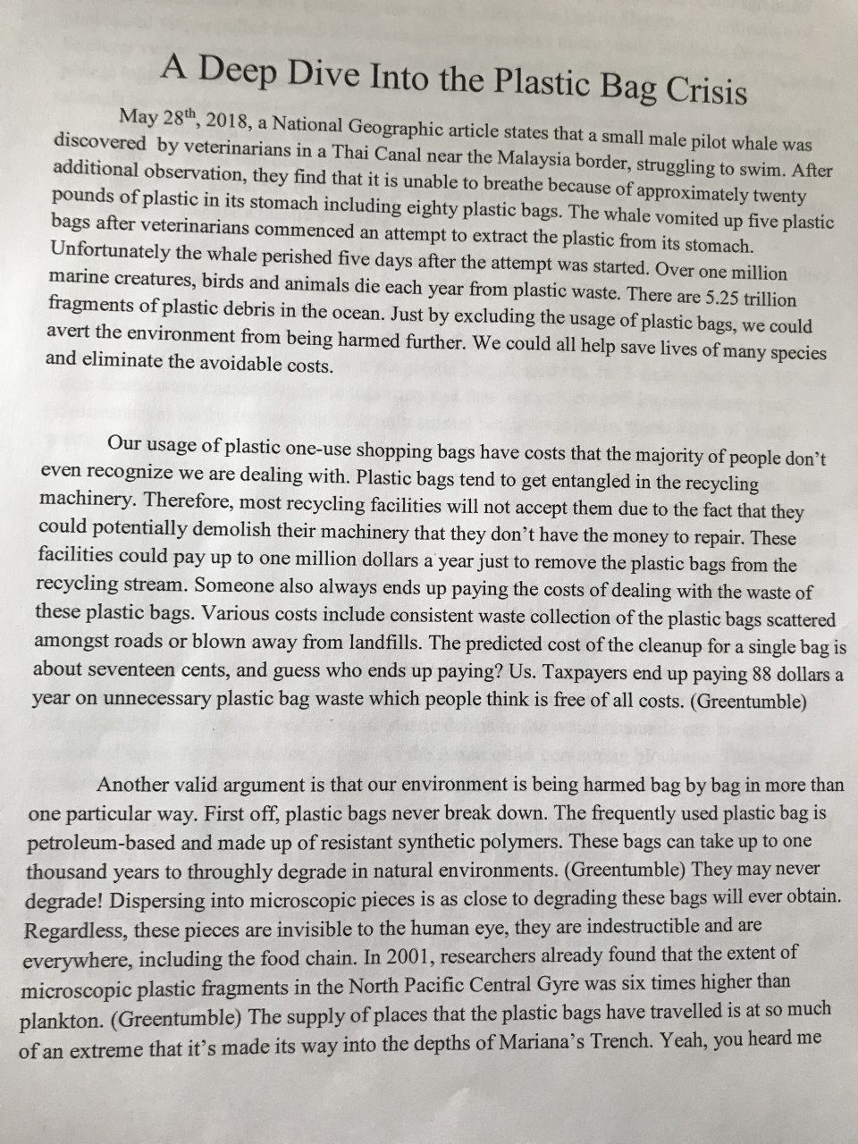
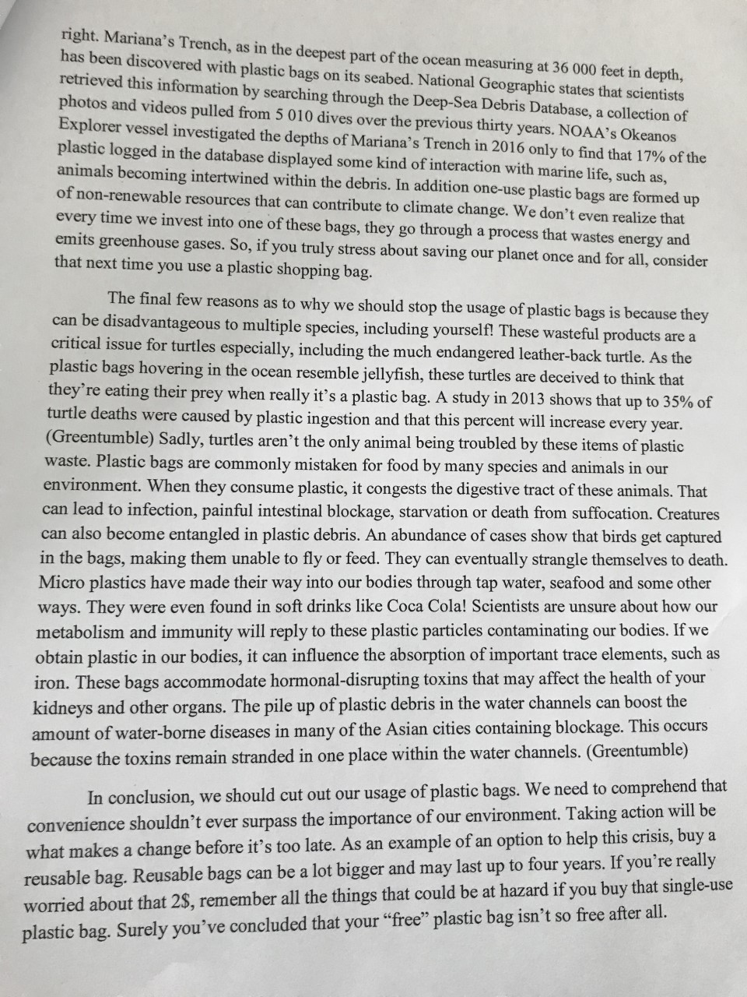

By looking at both of these essays you can see that there are some clear criteria that you need to follow when writing your essay:

- The essays have an introduction that includes a hook and a statement of the writer’s opinion on the topic.
- There are at least three supporting arguments for the writer’s opinion (each argument has its own paragraph).
- The conclusion is interesting and leaves the reader thinking.
- The writers have included evidence from online resources to support their opinions.

