How to Play KenKen

GOAL: Your goal is to fill in the whole grid with numbers, making sure no
number is repeated in any row or column.

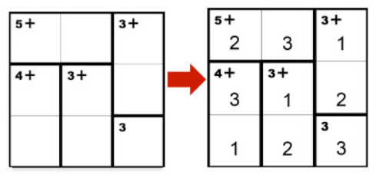

In a 3x3 puzzle, like the one below, use the digits 1, 2, 3.
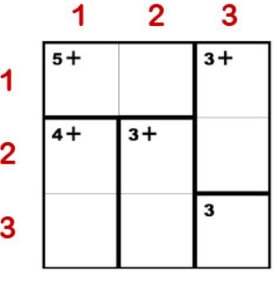

In a 4x4 puzzle use the digits 1, 2, 3, 4.
In a 5x5 puzzle use the digits 1, 2, 3, 4, 5… and so on.

The heavily outlined areas are called cages. The puzzle below has 5 cages.

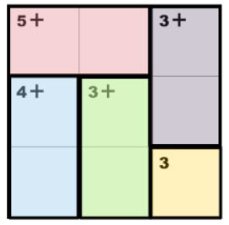

The top left corner of each cage has a target number and a math operation
(+, -, x, ÷). The numbers you enter into each cage must combine (in any order) to produce the target number using the math operation given.
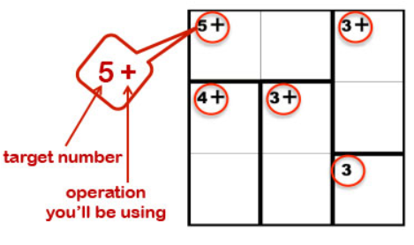

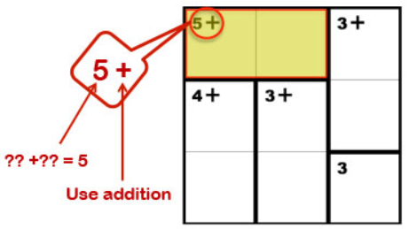
In this cage, the math operation to use is addition, and the numbers must add up to 5. Since this cage has two squares, the only possibilities are 2 and 3, in any order: (2 + 3) or (3 + 2).

A cage with one square is a “freebie”.
There is no operation so just fill in the
number you are given. If your puzzle has
one, you should always start with your
“freebie”!

A number cannot be repeated within the same row or column. If this happens you will have to do some rearranging!
Good luck!
