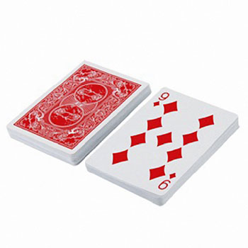
Multiplication War
(Version 1)

Number of Players: 2
Materials: Deck of playing cards (Ace = 11 and ALL face cards = 10)

How to Play:
- Shuffle the deck of cards and divide them evenly between the 2 players. Keep them face down. Do not look at your cards!

- Face your opponent. At the exact same time, each of you will take the top card from your deck and place it face up between you.

- Immediately multiply the two numbers and call out the answer. Whoever says the product first (correctly) wins both cards and places them at the bottom of his/her deck.

- If you say the product at the exact same time, you declare WAR! Together chant the words “I Declare War” and place 3 cards on the table from each of your piles. Put the first 2 cards face down and the third card face up and say the product. Whoever says the product first (correctly) wins all the cards on the table (8 cards).

- Repeat steps 2 – 4 until one person wins all the cards or the time is up. The person with the most cards is the winner.

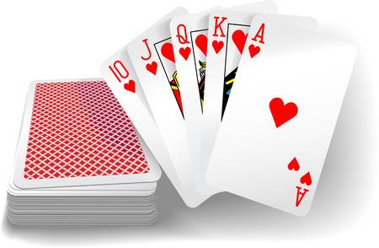

Multiplication War
(Version 2)

Number of Players: 2
Materials: Deck of playing cards (Ace = 11 and ALL face cards = 10)

How to Play:
- Shuffle the deck of cards and divide them evenly between the 2 players. Keep them face down. Do not look at your cards!

- Face your opponent. At the exact same time, both players will turn 2 cards face up from their pile and find the product of their own 2 cards.

- Once you have multiplied the two numbers on your cards call out the answer. The player with the largest product wins all 4 cards and places them at the bottom of his/her deck.

- If the product on each players card is the exact same, you declare WAR! Together chant the words “I Declare War” and place 3 cards on the table from each of your piles. Put the first card face down and the second and third card face up. Multiple the cards and say the product. The player with the largest product wins all the cards on the table (10 cards).

- Repeat steps 2 – 4 until one person wins all the cards or the time is up. The person with the most cards is the winner.

