Round 2: Writing from Home:
Now that we are getting used to being at home, here are some different writing topics. We would love to read what you are writing. Email or send a picture. We miss all of you.
Choose any of the following. (If choosing a picture, you may write a story, describe the picture, or respond with any thoughts or feelings it creates)
 | Create a list of 5 things you want to do with your friends when you can get together again. Explain why you chose these things. | You are living through history right now.  Begin creating a time capsule to be  opened years from now. Choices could  include 3 or more of the following: Write  a journal entry of one of your days;  create a piece of art; find a news article  to keep; share a special memory;  take some photos; make a list of the  biggest changes in your life right now.  You can choose to work on this  more than one day this week!
Make a bucket list of 3-5 places you would like to visit. What do you want to do or see at each place? | DEAR TEACHER  Write a letter to me, explaining what you have been doing, what you miss doing, and what you plan to do soon. | 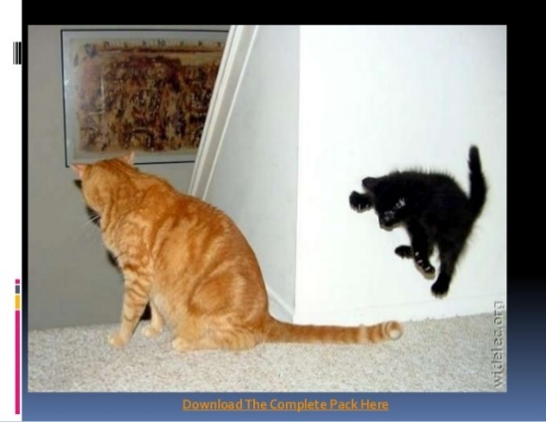
STRANGE HAPPENINGS  Write a story that begins with:  I knew this was not my home planet but I had no idea how far from “home” I was. | 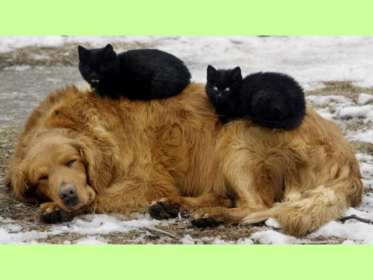 | April is the month of Venus. Search  the sky to see if you can find this  planet which will shine its brightest  this month!  Watch https://www.jpl.nasa.gov/video/details.php?id=1612 to learn about other stars you might see in our sky this month.

You can write about any topic of your choice: fiction (made-up) or non-fiction (true) that is interesting to you.

