Types of Maps – Group Work Graphic Organizer
Type of Map | Key attributes of this type of map (key things you notice that are on it) | Purpose of this type of map (what it can be used for) | Advantages of this type of map | Disadvantages of this type of map
Street

Topographic

Political

Map Type #1: Street Map
What is a street map?
Street maps usually cover an area of a few miles or kilometers (at most) within a single city or extended metropolitan area.
The digital mapping revolution caused an explosion of map creation in the 1990s. In 1996, MapQuest, the first popular online mapping service, allowed anyone with internet access the ability to create customized maps of almost any location in the United States.
Within a few months, millions of people had become “cartographers”. They were soon producing more unique maps in a single day than had been created during the entire history of paper cartography!
Today, Google Maps is the world's most popular online mapping system. In addition to maps, the service also provides travel route directions. It can create directions for people who are driving, taking public transportation, walking, cycling or taking a plane.
Billions of unique maps, millions of travel routes, and millions of street views are created each day with Google Maps. It is the first place millions of people go to plan any type of travel.
"Google Earth" also allows people to view streets, roads and satellite images within a single interface.
GPS also makes frequent use of street maps.
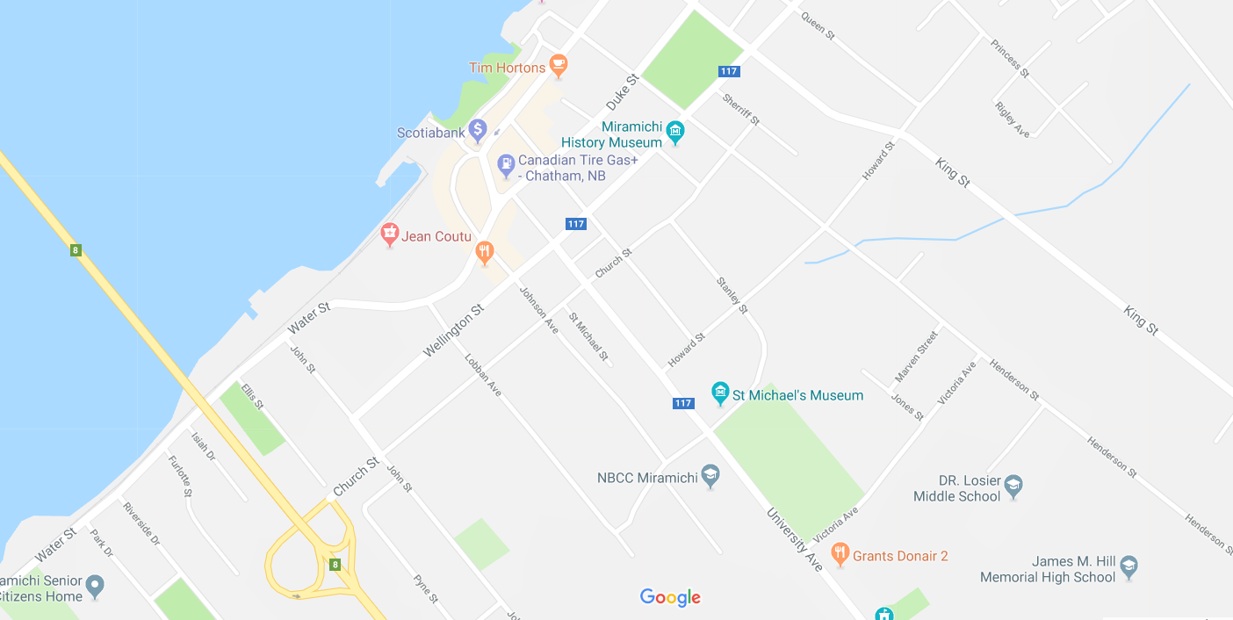
Example:
Map Type #2: Topographic Map
Topographic maps are reference maps that show the shape of Earth’s surface. They usually do this with lines of equal elevation known as “contour lines”, but elevation can also be shown using colors (second map), color gradients, shaded relief and a number of other methods.
Topographic maps are frequently used by hunters, hikers, skiers, and others seeking outdoor recreation. They are also essential tools of the trade for geologists, surveyors, engineers, construction workers, landscape planners, architects, biologists and many other professions - especially people in the military.
Topographic maps also show other important natural features such as lakes, rivers and streams. Their locations are determined by topography, making them important natural elements of topographic maps.
Important cultural features are also shown on topographic maps. These include roads, trails, buildings, place names, bench marks, cemeteries, churches, schools and much more. A standardized set of special symbols has been developed for this use.
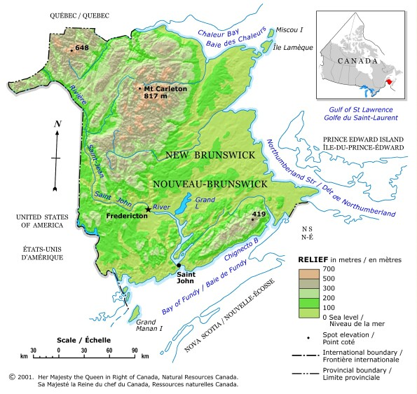
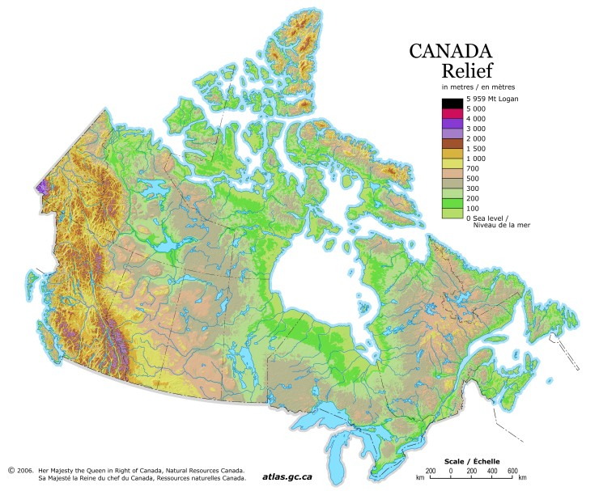

Map Type #3: Political Map

What is a Political Map?
A political map is different than other types of maps because it focuses on government or administrative boundaries rather than geographical or physical features. Instead of showing viewers what exists in the land, it shows those imaginary lines that serve to separate countries, states, territories, and cities. These maps generally include larger bodies of water, such as oceans, rivers, and lakes, as landmarks. In fact, in many places, a coastline or river will serve as a political border. In contrast the many different types of physical maps emphasize the topographical, climate, geological or other features of an area. In these maps, political borders or even the existence of towns and cities are only used as reference points.
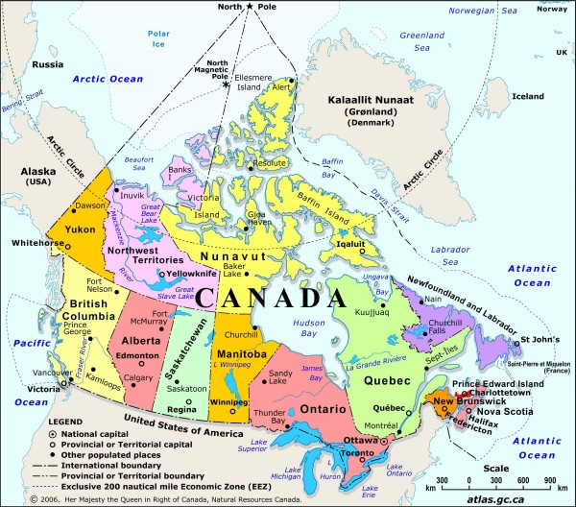
It makes sense that political maps are in heavy use in early childhood education. Helping children to understand the world around them is best achieved by starting with broader concepts such as the existence of countries and states and how they relate physically to one another. A globe, atlas, or wall map for children is going to emphasize these territorial borders usually with bright colors and bold outlines.
There are some faults with political maps. Because the intent of these maps is to show territory owned or controlled by government entities, there is less attention given to accuracy in physical depiction. The projection of a given map can be skewed in order to make countries look larger or more menacing than they actually are.

