Grade 8 ELA –June 1st – 12th

Reading  and Viewing | - Critical reading focus –  - Analyzing poetry – identifying figurative language, recognizing the effect of figurative language on sound and meaning, identifying theme.  - Personal reading– Choose a poem or song and create a reading response. Feel free to create your own response (writing or drawing) or use one of the following prompts to help you:  - Why do you like the poem or song? How does it make you feel?  - What do you visualize when reading/listening to the poem/song? Draw or write about it.  - What does the poem/song remind you of?
Speaking and Listening  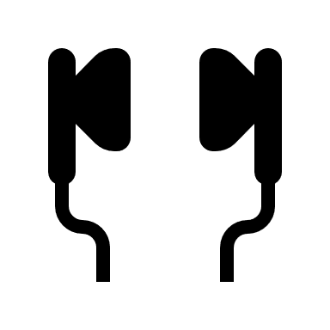 | - Spend time over the next two weeks listening to songs. Challenge yourself to listen to some poems as well. It is interesting to hear poets reading their own work.
Writing | All writing tasks can be completed directly on the PowerPoint slides, in your writers notebook, or in the Notes App on your phone.  - If you have not done so, send me the final copy of your persuasive essay.  - Online magnetic poem  - Reading response to a poem/song  - Poetry/Song Analysis

