Grade 8 Persuasive Essay Workbook – May 11th-18th Name:

Sequence of the Unit:

April 20th-27th:
What is a persuasive essay? It is important to start by investigating what good essays look like. You have all practiced “reading like writers” during our narrative unit in the fall. Now you will apply these skills to persuasive texts. Once you have a grasp of what an effective persuasive essay looks like, you will begin the process of writing your own persuasive essay. DONE! WOOHOO!

April 27th – May 4th:
Choosing a topic. You will work on narrowing down a topic that is of interest to you.
Collecting Information. You will learn about research strategies, particularly regarding online sources. You will find three sources of information on your topic. DONE! WOOHOO!

May 4th – 11th:
Prewriting. After you have your information, you will use a position/support web for the preliminary organization of your information.
Writing an Introduction. You will explore different types of leads, the elements of an introduction, and then you will write your own introduction.
Writing the Thesis Statement. You will learn how to write a sentence that states your opinion on the topic. DONE! WOOHOO!

May 11th-18th:
- How to Avoid Plagiarism. In this section, you will learn how to avoid plagiarism in your writing. This includes how to incorporate quotes and put research into your own words.
- Writing an Effective Body Paragraph. You will learn how to organize the body and supporting arguments and details. Then you will complete a draft of the first body paragraph of your essay (the other body paragraphs will be completed next week).

Persuasive Writing Process (use this as a checklist as you move through the process):

- Prewriting:
Choosing a topic
Researching
planning
- Drafting:
Writing an effective introduction
  - Writing strong paragraphs
  - Incorporating quotes
  - Paraphrasing
  - Transition words
  - Writing effective conclusions
- Revising and Editing
  - Use the essay skills checklist to revise and edit your piece
- Publishing
  - Typing or printing the final copy

Drafting the Body: Once the draft of your introduction is finished, you are ready to move on to the body of the essay. This is where you will present your evidence.

We also have some important mini-lessons to cover in this section:

- how to write an effective paragraph
- incorporating direct quotes from research
- paraphrasing information from our research

How to use words and ideas from your research in your writing:
- When you take another author's words or ideas, copy them in your writing, and claim them as your own, it is called plagiarism.
- So, if we are using research in this essay, which means someone else’s words, how do we do this without plagiarizing? There are two ways…paraphrasing and quotations. Because we are incorporating research into our essays, we must use one or both of these methods.
- Quotations are when you use the exact words of the original author. You must put quotation marks around the sentence.
- Paraphrasing involves putting a piece of someone else writing or thoughts into your own words. You must still mention the author who wrote it originally.
- Be careful when you paraphrase to avoid both
a. the original writer's words and
b. the original writer's style.

Let’s start with paraphrasing… How do I borrow from a source without plagiarizing? Anytime you are taking information from a source that is not your ​own, you need to specify where you got that ​information.
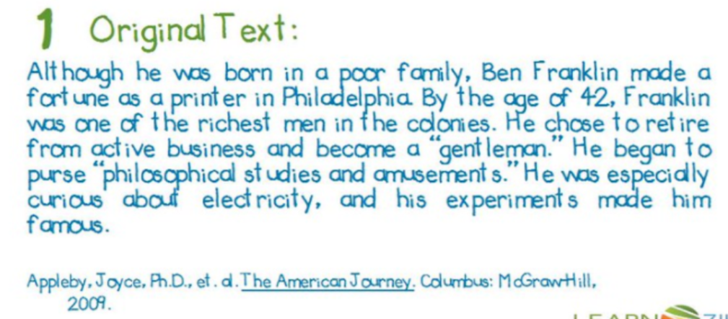
Example –
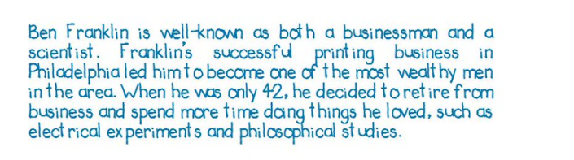
Paraphrased passage:

How is the paraphrase similar and different to the original text?
Similar: the key points are the same
Different: the style of the writing. In the original, it is the professional writer’s style. In the paraphrase, it is the student’s writing style in his/her own words.

Three steps for effective paraphrasing:
1) Reread the original passage until you understand its full meaning.
2) Set the original aside, and write your paraphrase in your writers notebook. Start your paragraph with “According to (the author’s name or the website)”.
3) Check your piece with the original to make sure that your version accurately expresses all the essential information in a new form.

Try Paraphrasing On Your Own!
Read the following passage on orcas (killer whales) and paraphrase it in your own words. This will be handed in for marks.
REMEMBER:
1. The paraphrase must be entirely in your own words.
2. You must do more than merely substitute phrases here and there. It should sound like your voice.
3. Somehow indicate where the ideas came from. Ex: According to Wikipedia…
ORCA – Killer Whales
This distinctive black and white toothed cetacean (whales, dolphins and porpoises) can be found in oceans worldwide. Also known as the killer whale, the orca is an excellent hunter. All types of fish — from herring to white sharks, to marine mammals such as whales and seals, and even turtles and birds — are not safe when the orca is nearby.
Orcas have perfected several inventive techniques to catch their prey. One method is for large groups of orcas to work as a team to herd victims together before attacking from different angles. Orcas will also frequently force seals and sea lions to beach, giving the hunter an easy catch in the shallow water. Tipping over ice floes to unbalance a tasty meal is another trick. (animalplanet.com)
Your paraphrase:

Including Quotes: So if paraphrasing allows you to incorporate another writer’s ideas into your own writing, how to you include another writer’s ideas “word for word”? When you include a line word for word from your research, it is called a quote. If you would like to do this, you must put quotation marks around the line. You should include the author in the introduction to the quote or in brackets after the quote.
There are two ways to do this:
- Author’s name is mentioned in the introduction to the quote. Ex: As Carol Welch stated, “Movement is a medicine for creating change in a person’s physical, emotional, and mental states.”
- Author’s name is put in brackets after the quote. Ex: “Hunters registered a total of 7,753 deer bagged in New Brunswick last year. That number will be around the 6,500 mark this year, according to Cumberland” (Huras).

What should the body of my essay look like? (Refer to slide 12 in the PowerPoint for a visual example)
- Minimum of three paragraphs
- Each paragraph should focus on one of your “reasons” from your position/support web
- Use the defending details for each “reason” to create your paragraph

How to write an effective body paragraph – Each paragraph should include a topic sentence, 2-3 supporting/defending details, and a conclusion sentence. Your defending details come directly from your position/support web. (Refer to slides 13-17 for a visual example).

Topic Sentence
Detail

Detail
Concluding Sentence
Feeling unsafe is a reason why a lot of people choose not to ride their bikes on the streets. You may say they’re “overreacting”, however, according to a Statistics Canada report that looked at deaths related to cycling between 1994 and 2012, a total of 1 408 deaths were recorded — an average of 74 accidents a year. That doesn’t include the other 7 500 people with serious injuries related to cycling. You can’t tell me that they’re overreacting now, can you? Bike lanes allow cyclists to ride at their preferred speed without the fear of cars not seeing them or just not giving them a respectable distance.

