Grade 8 Persuasive Essay Workbook – May 18th – 25th Name:

Sequence of the Unit:

April 20th-27th:
What is a persuasive essay? It is important to start by investigating what good essays look like. You have all practiced “reading like writers” during our narrative unit in the fall. Now you will apply these skills to persuasive texts. Once you have a grasp of what an effective persuasive essay looks like, you will begin the process of writing your own persuasive essay. DONE! WOOHOO!

April 27th – May 4th:
Choosing a topic. You will work on narrowing down a topic that is of interest to you.
Collecting Information. You will learn about research strategies, particularly regarding online sources. You will find three sources of information on your topic. DONE! WOOHOO!

May 4th – 11th:
Prewriting. After you have your information, you will use a position/support web for the preliminary organization of your information.
Writing an Introduction. You will explore different types of leads, the elements of an introduction, and then you will write your own introduction.
Writing the Thesis Statement. You will learn how to write a sentence that states your opinion on the topic. DONE! WOOHOO!

May 11th-18th:
How to Avoid Plagiarism. In this section, you will learn how to avoid plagiarism in your writing. This includes how to incorporate quotes and put research into your own words.
Writing an Effective Body Paragraph. You will learn how to organize the body and supporting arguments and details. Then you will complete a draft of the first body paragraph of your essay (the other body paragraphs will be completed next week). DONE! WOOHOO!

May 18th-25th:
- Finish Drafting the Body. Continue drafting the body of your essay. You need two more paragraphs (or more) to complete the body. There is also a short mini-lesson on using transition words in persuasive writing.

Persuasive Writing Process (use this as a checklist as you move through the process):

- Prewriting:
Choosing a topic
Researching
planning
- Drafting:
Writing an effective introduction
Writing strong paragraphs
Incorporating quotes
Paraphrasing
  - Transition words
  - Writing effective conclusions
- Revising and Editing
  - Use the essay skills checklist to revise and edit your piece
- Publishing
  - Typing or printing the final copy

Using Transition Words: A persuasive essay is a perfect opportunity to use transition words. These are words that help the writer to transition between ideas. Here are some examples:

- As a result
- However
- Therefore
- Thus
- Consequently
- Although
- By contrast
- To conclude
- In addition
- Moreover
- Furthermore
- In particular

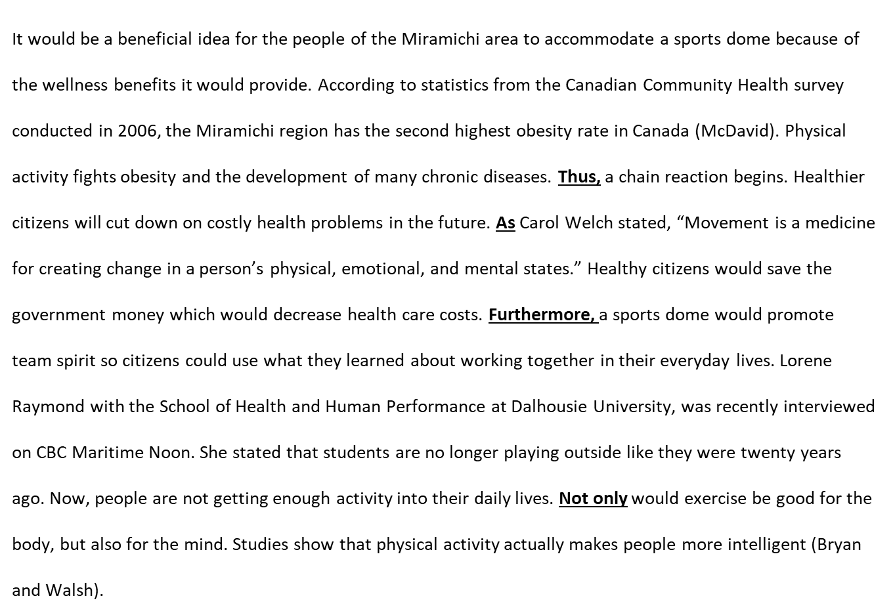
Here is an example of a former student’s essay. Note the use of transition words:

Now it is your turn to write the body of your essay. Remember to consider your writing traits while writing: voice, word choice, conventions, sentence structure. You may type your body below.

Wondering if you’re on the right track? Here is a copy of the Grade 8 standards for persuasive writing:
 | Strong | Proficient | Acceptable | Developing | Beginning
Ideas and Content | Takes a clear position and supports it consistently with thoughtful and original reasons/ research and background information and/or examples. | Takes a clear position and supports it with relevant reasons/ research and background information and/or examples through much of the essay. | Takes a clear position and supports it with some relevant reasons and/or examples; some reasons require more detail to support. | Position is unclear; supporting details are too general or off-topic. | Position is unclear; supporting details are minimal or non-existent.
Organization | Organized in a logical manner; paragraphing is varied for creative effect and makes use of effective transitions. Creative and engaging introduction and conclusion. | Logical order and structure. Proper use of paragraphing and transitions. Inviting introduction and satisfying closure. | Is generally organized with appropriate paragraphing and adequate use of transitions between sections. Basic introduction and conclusion. | Is organized in parts of the essay; other parts are disjointed and/or lack transitions. Ineffective use of paragraph breaks. Introduction and conclusion are unclear. | Is disorganized or unfocused throughout much of the essay. Introduction and/or conclusion lack development.
Voice | Skillfully connects with the audience. Demonstrates strong conviction and commitment to the topic. Develops ideas in a unique or unusual way, revealing the writer’s perspective (persuasive strategies). | Tailors their message to the audience. Shows care and commitment to the topic. Writer behind the words comes through. Use of some persuasive strategies to create voice. | Appropriate to audience and purpose. Persuasive tone is used throughout the essay. | Tone is not appropriate to the audience and/or purpose. A lack of persuasive devices leads the writing to sound mechanical. | Little or no hint of the writer behind the words. Persuasive devices are not used.
Word Choice | Effectively includes vivid vocabulary/precise technical words, which energize the writing. | Includes interesting words and/or technical/subject-specific language to enhance meaning. | Language is functional and appropriate. Some interesting words are used to enhance meaning. | Word choice may be accurate, but there is no attempt at deliberate choice of words that enhance meaning. | Word choice has not been considered and may often be inaccurate.
Sentence Fluency | High degree of craftmanship with a striking variety of complex sentence structures and types. | Includes different kinds of sentences, with a variety of sentence lengths and beginnings to create fluidity. | Generally in control. Some variety in length and structure. | Some awkward constructions with many similar patterns and beginnings. Some run-on/fragment sentences. | Sentence structure impedes readability. Frequent run-on/fragment sentences take away from fluidity of piece.
Conventions | Uses conventions skillfully to enhance meaning and voice (conventional artistry). Strong control of standard conventions of writing, including internal punctuation, correctly spelling most words, and proper use of grammatical structures. | Strong control of standard conventions of writing, including internal punctuation, correctly spelling most words, and proper use of grammatical structures; errors are few and minor. Takes some risks with conventional artistry. | Control of most writing conventions; errors are few and minor. | Errors in grammar, spelling, and punctuation sometimes interfere with understanding. | Frequent significant errors, which impede readability.

