Grade 8 Persuasive Essay Workbook – May 4th – 11th Name:

Sequence of the Unit:

April 20th-27th:
What is a persuasive essay? It is important to start by investigating what good essays look like. You have all practiced “reading like writers” during our narrative unit in the fall. Now you will apply these skills to persuasive texts. Once you have a grasp of what an effective persuasive essay looks like, you will begin the process of writing your own persuasive essay. DONE! WOOHOO!

April 27th – May 4th:
Choosing a topic. You will work on narrowing down a topic that is of interest to you.
Collecting Information. You will learn about research strategies, particularly regarding online sources. You will find three sources of information on your topic. DONE! WOOHOO!

May 4th – 11th:
- Prewriting. After you have your information, you will use a position/support web for the preliminary organization of your information.
- Writing an Introduction. You will explore different types of leads, the elements of an introduction, and then you will write your own introduction.

Persuasive Writing Process (use this as a checklist as you move through the process):

- Prewriting:
Choosing a topic
Researching
  - planning
- Drafting:
  - Writing an effective introduction
  - Writing strong paragraphs
  - Incorporating quotes
  - Paraphrasing
  - Transition words
  - Writing effective conclusions
- Revising and Editing
  - Use the essay skills checklist to revise and edit your piece
- Publishing
  - Typing or printing the final copy

STEP ONE CONT…
Planning:

  - Now that you’ve completed the research on your topic, it is time to plan out your essay. I know what you’re thinking…can’t we get to the writing of this thing already? It is important to give extra time to planning a persuasive essay. That will make the writing of the essay a lot easier. Would you build a house without a blueprint?

  - We recommend using a position/support web to organize your ideas. When using the web, you will do the following:
  - Your position (opinion) goes in the middle
  - Your three reasons to support go in the bubbles around the outside.
  - Next, try to find supporting details for each reason. You should have at least two for each.

Position/Support Web

NAME_______________________________________________________________
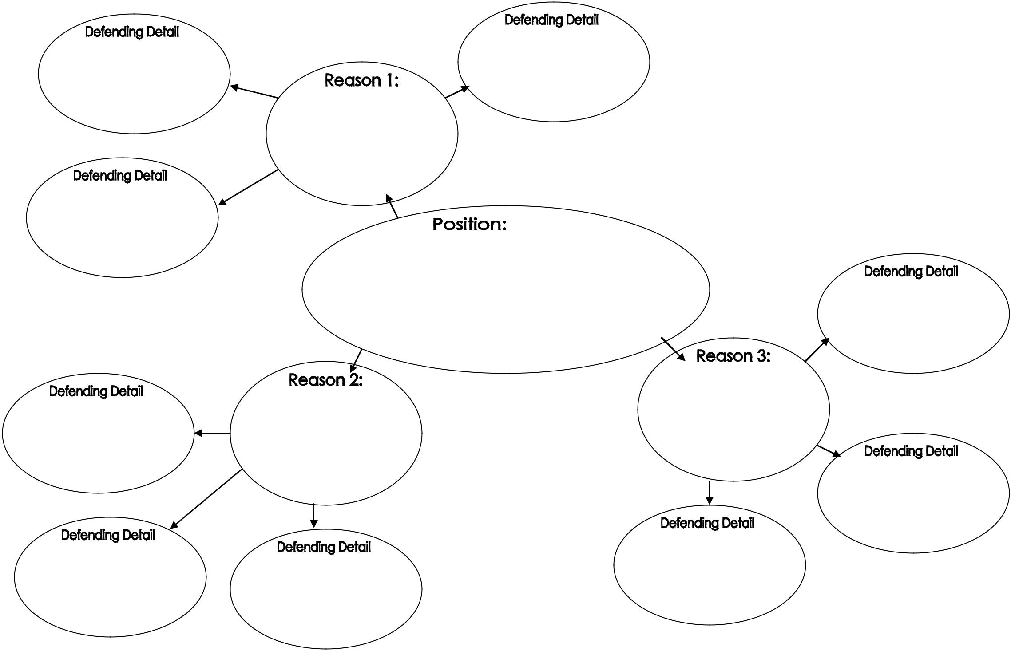

STEP TWO: DRAFTING

Writing the Introduction:
- A good introduction has two things: a hook to capture the reader’s attention and a thesis that states your argument. (Refer to slides 46 and 47 on the PowerPoint for a visual)

- Your task: In the space below, draft your introduction. Remember to include a hook and a thesis that states your argument.

