Grade 6 and 7 Literacy Choice Board

Read for 30 minutes each day. Record what you read.
Choose one writing choice from the grid below each day.
What is something you have always wondered about? Write a list of things you wonder about and choose one to research and try to find answers for. Write out what you learned to share with other people who may wonder the same thing. | 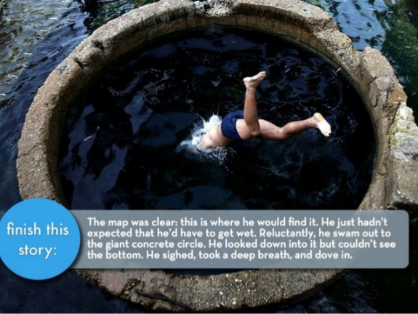 | Write your thoughts on home learning. Do you like it better or would you prefer going to classes? Do you think home learning works better for certain age groups or certain personalities?
How did the new guidelines presented by Premier Higgs change your and/or your family’s life? Did including another household in your “family bubble” make a big difference or not? Journal about it. | Go to YouTube and listen to a few songs about Covid-19 that people have come up with. Write a song of your own expressing your thoughts. You can simply change the words to a song you know or put your words to a well-known tune. Record it and share. | Make a list of all the things you have done to pass time during all these weeks of being home that you wouldn’t have done normally. Perhaps it’s a jigsaw puzzle, online game, board game, cooking, etc. How many can you come up with? Get a friend or family member to make a similar list and compare.
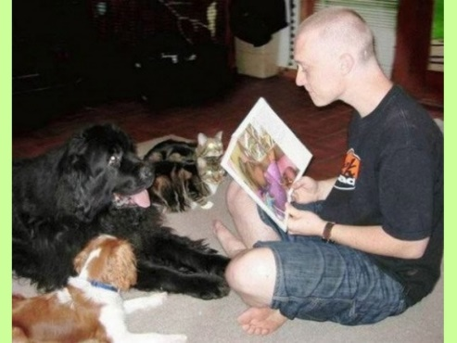 | Do you believe physical activity helps your mind? Do an experiment with yourself and see if doing something physical helps you think more positively. Why or why not? | There has been a lot of research that proves that helping others helps you feel better. Think of something you could do to help one of your neighbours, family or friends during this difficult time. Do it and then write to describe what you did and how it made you feel.

Create an acrostic poem to give to someone special for Mothers’ Day.
To create an acrostic poem, follow these five easy steps:
- Decide what to write about.
- Write your word down vertically. MOTHER/GRAMMY/NANA/KOOKUM/ MERE
- Brainstorm words or phrases that describe your mother /grandmother or other important person in your life.
- Place your brainstormed words or phrases on the lines that begin with the same letters.
- Fill in the rest of the lines to create a poem. It does not have to rhyme!

You can also click on the link below to view a short video explaining acrostic poems.

https://www.youtube.com/watch?v=ybexYTzmZ5Y

