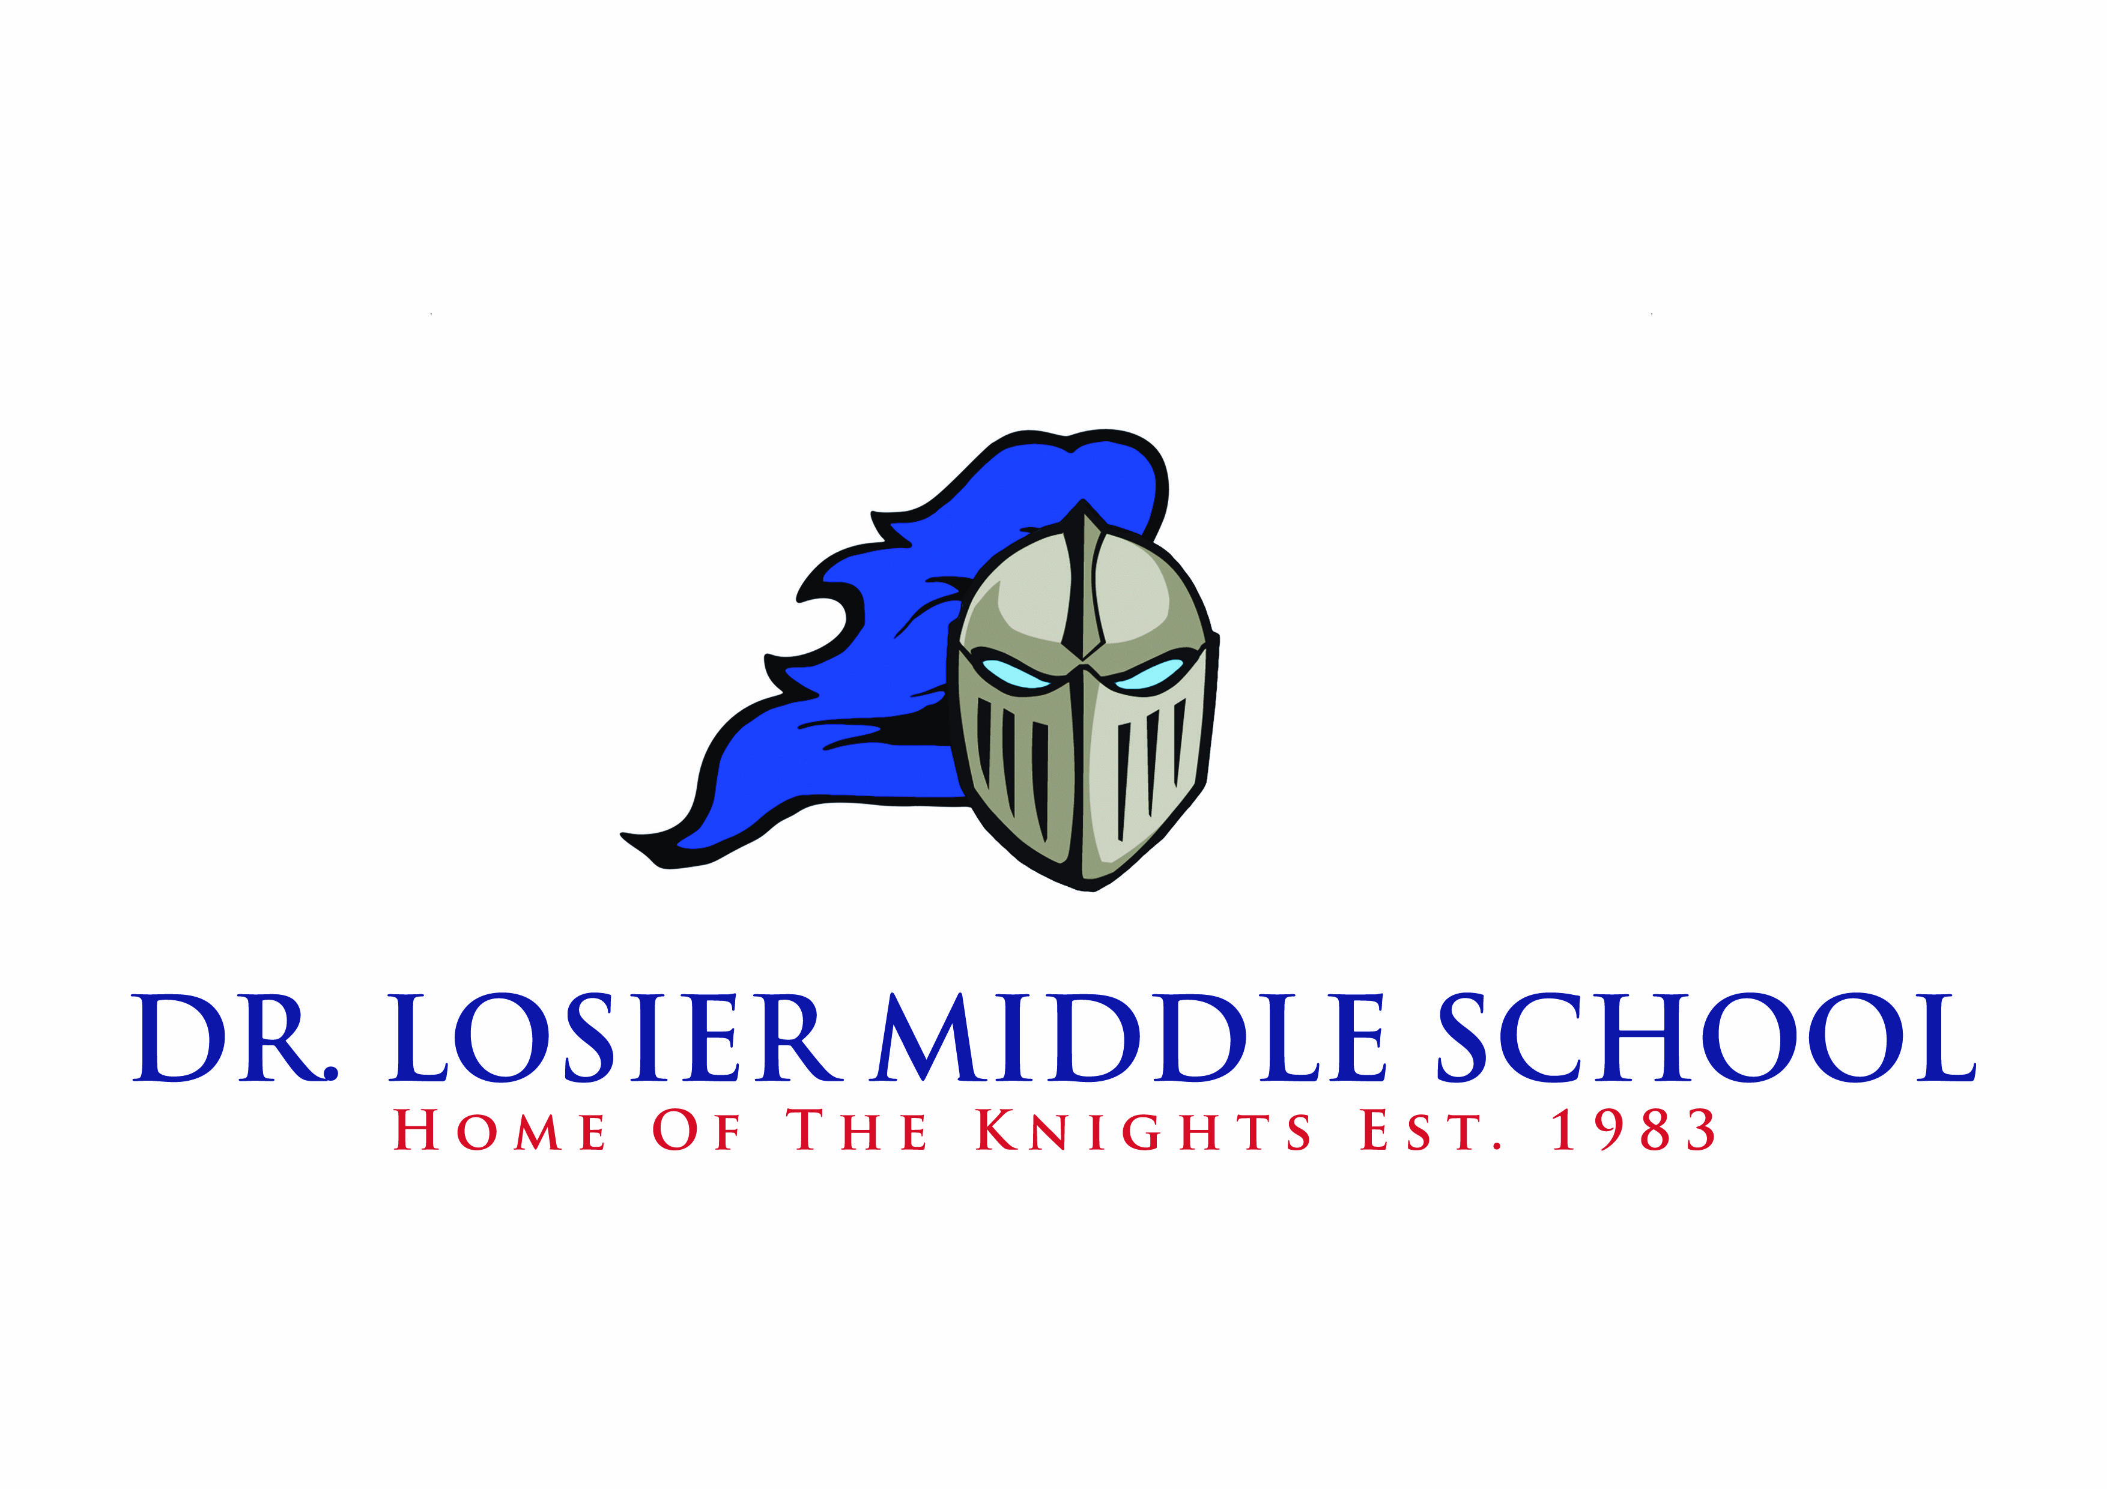

124 Henderson Street Miramichi, NB E1N 2S2
drlosier.nbed.nb.ca

Judson Waye Krista Cabel
Principal Vice Principal

Fall 2020 Parent-Teacher Interviews
Thursday, December 3rd 6:00-8:00pm
Friday, December 4th 9:00-11:30am

Hello DLMS Community!

As you may have heard, Parent-Teacher Interviews will be taking place virtually this year. Interviews will be held during the days and times noted in the school calendar, however, due to the coronavirus pandemic, they will take place via telephone.

If you would like to schedule an appointment to speak with a teacher, you can do the following:

- Contact the teacher via email to arrange for a phone interview during the above times. Please make contact with the teacher prior to December 3rd to arrange an interview time.
- If you do not have access to email, you may contact the school at 778-6077 to arrange for an interview. This option is only to be used if you do not have access to email.
- Provide the teacher with a phone number for the teacher to call at a pre-determined time for the phone-based interview.
- The teacher will respond to the email to arrange a time to call during the above times.

On December 3rd and 4th, teachers will call parents at the pre-arranged time to conduct the Parent-Teacher Interview. We anticipate that there will be many parents to call, so we ask that interviews be limited to ten minutes, unless there are exceptional circumstances.

Teacher emails can be found on the “Staff” tab of the DLMS website: drlosier.nbed.nb.ca

We look forward to speaking with our parents next week!

Thank you!

